**Express:**

* Express is a backend web application framework for building RESTful APIs with NODEjs.

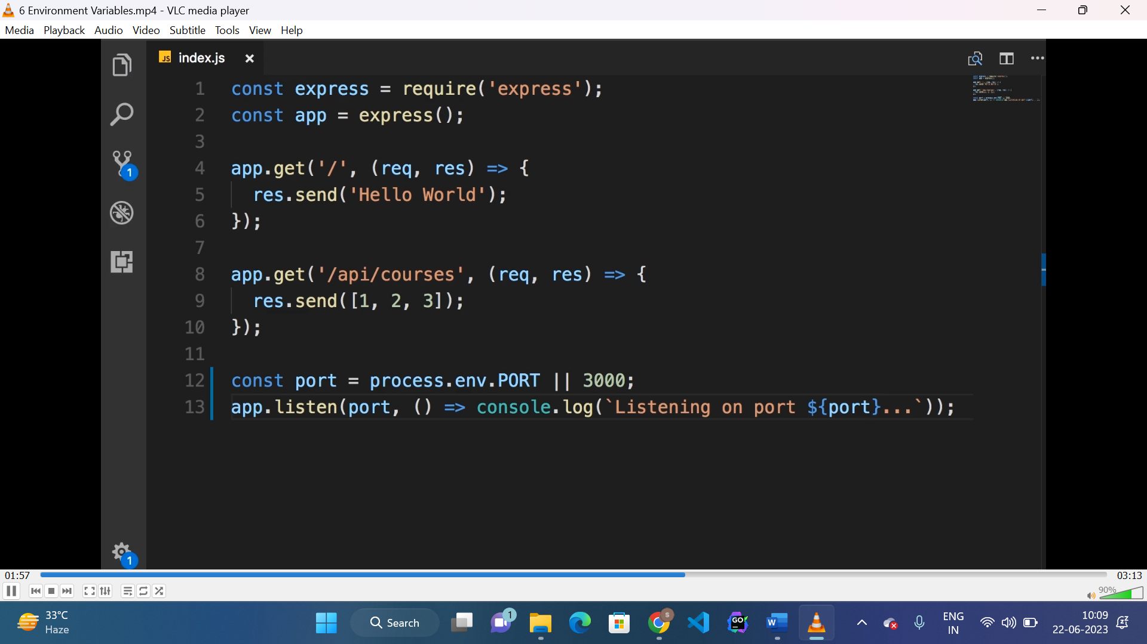

**Env variable:**

* To process environment variables “process.env.variablesName” is used.

**Getting URL & query params:**

* URL parameters can be accessed using the “req.params” object.
* Here req.params is

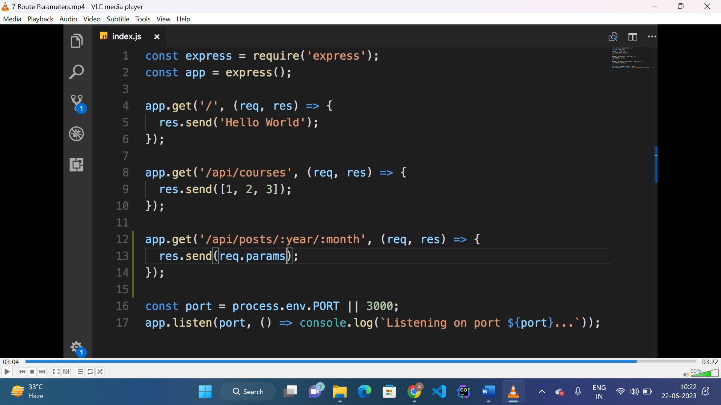

* To access query params we use “req.query” object
* Here req.query is 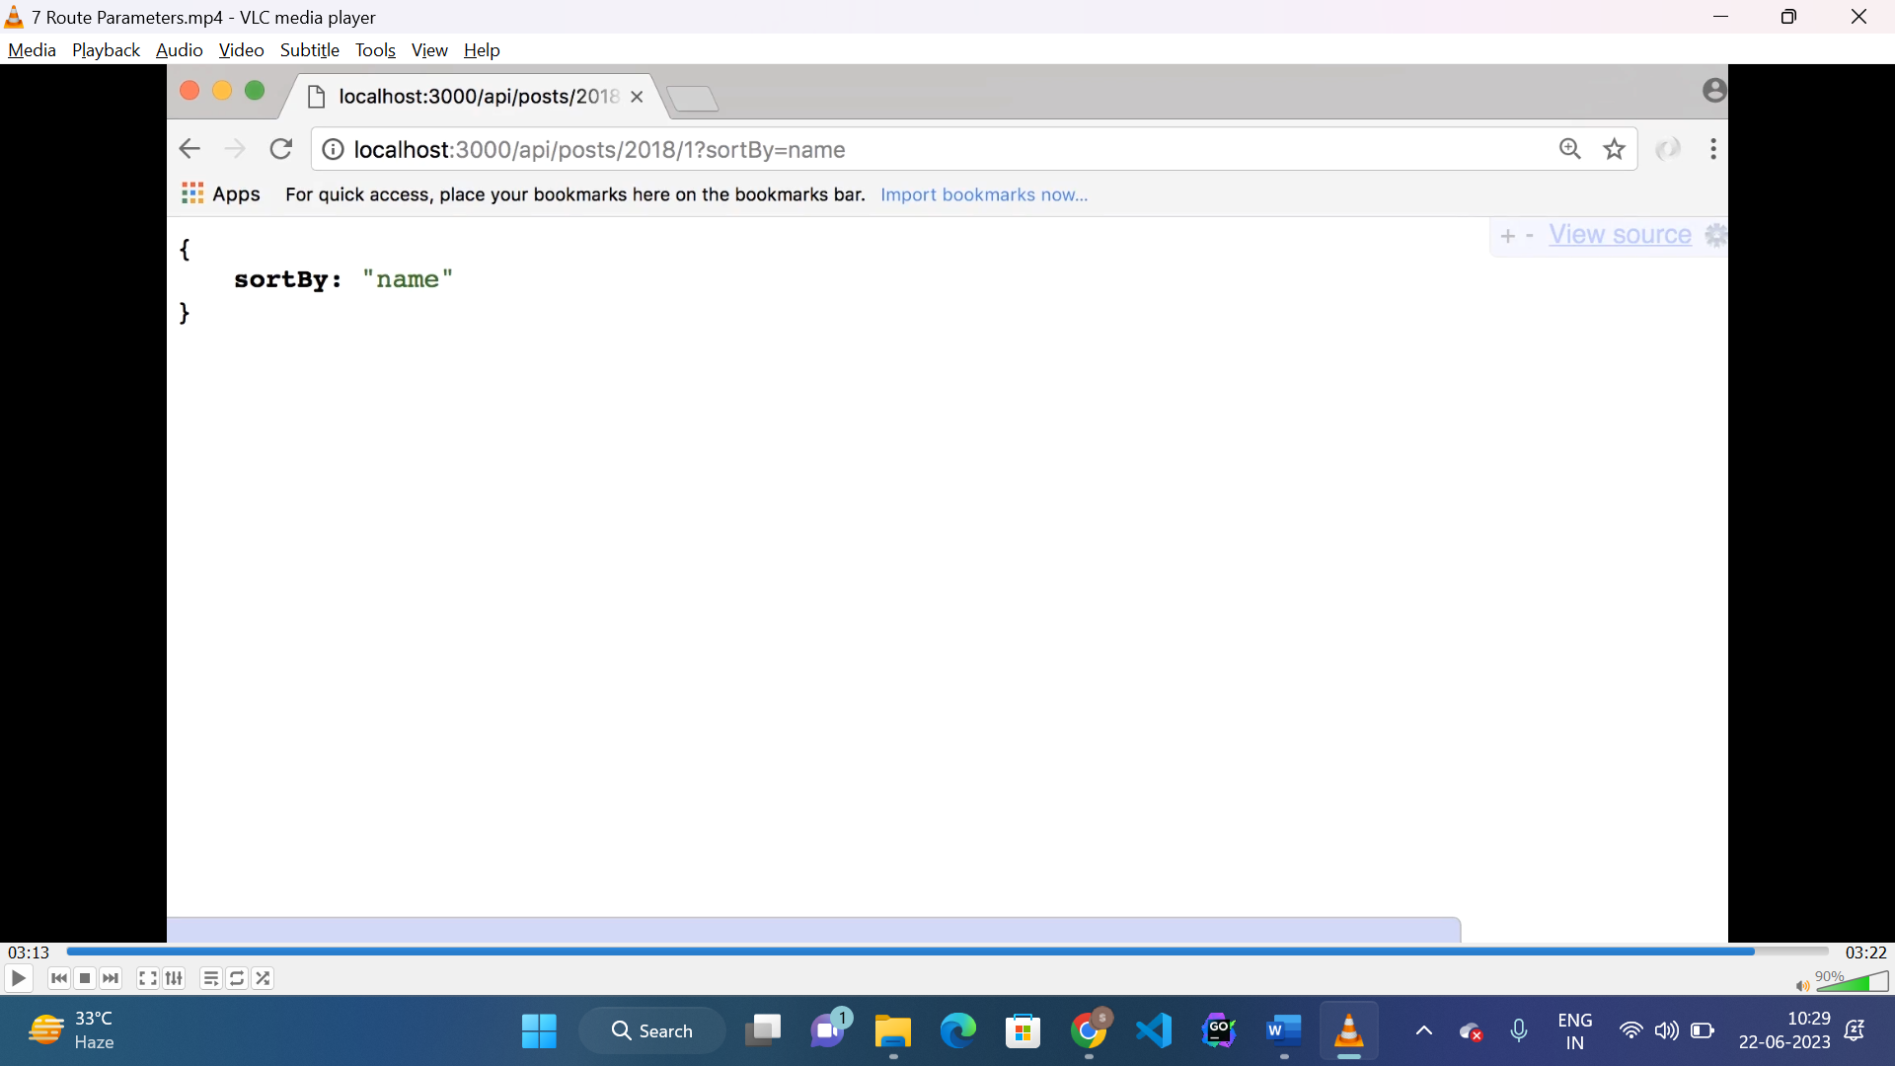

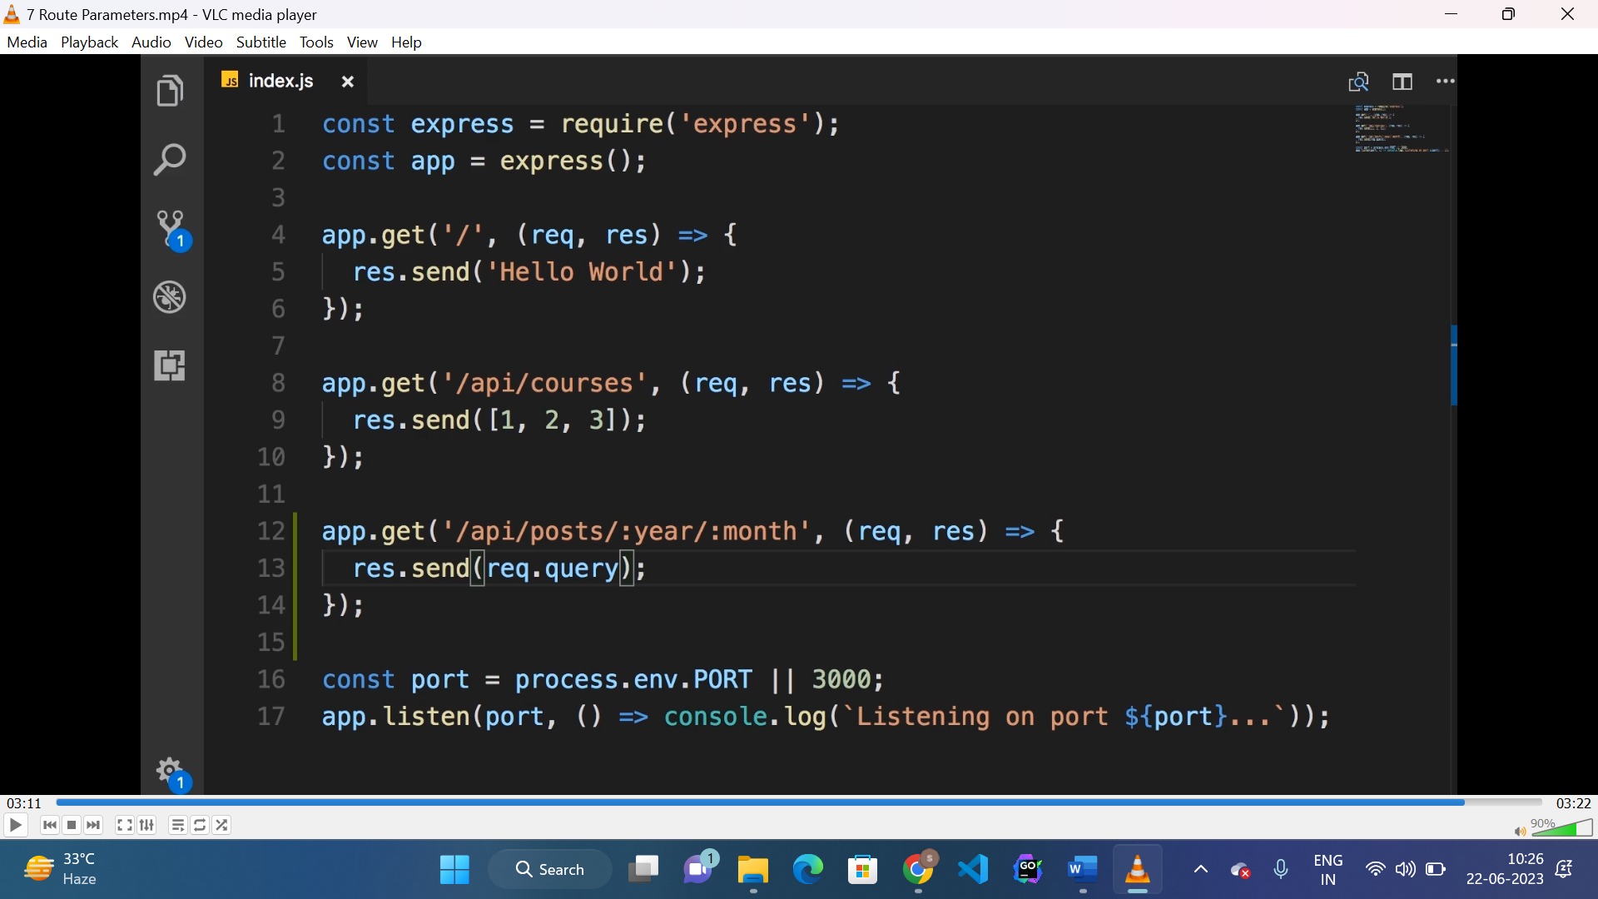

**Handling HTTP request(GET):**

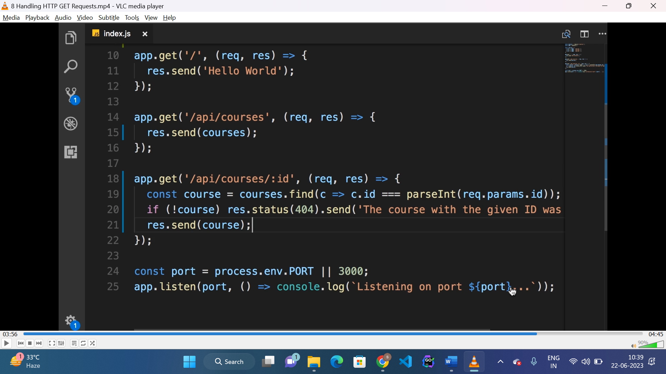

* To write status code we use “res.status(404).send(message)”
* “Course.find()” is used to iterate courses, find course and return matched course.

**POST request:**

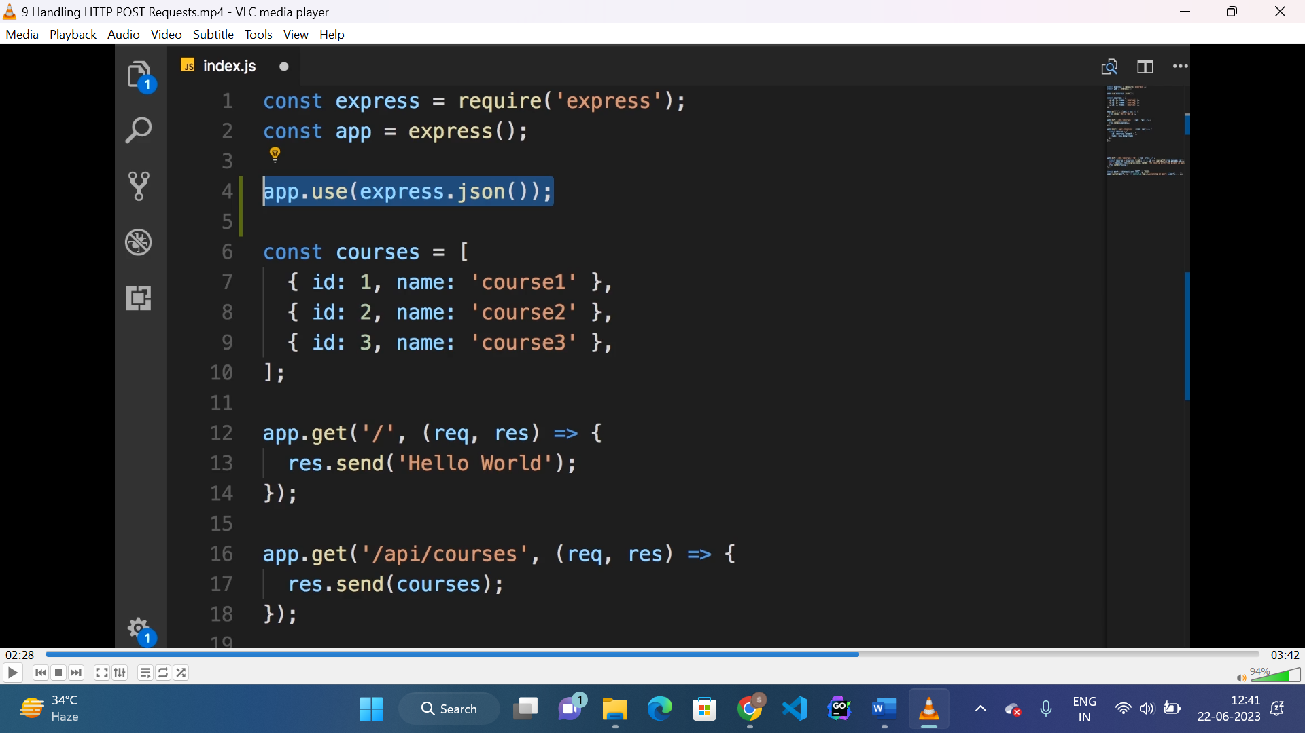

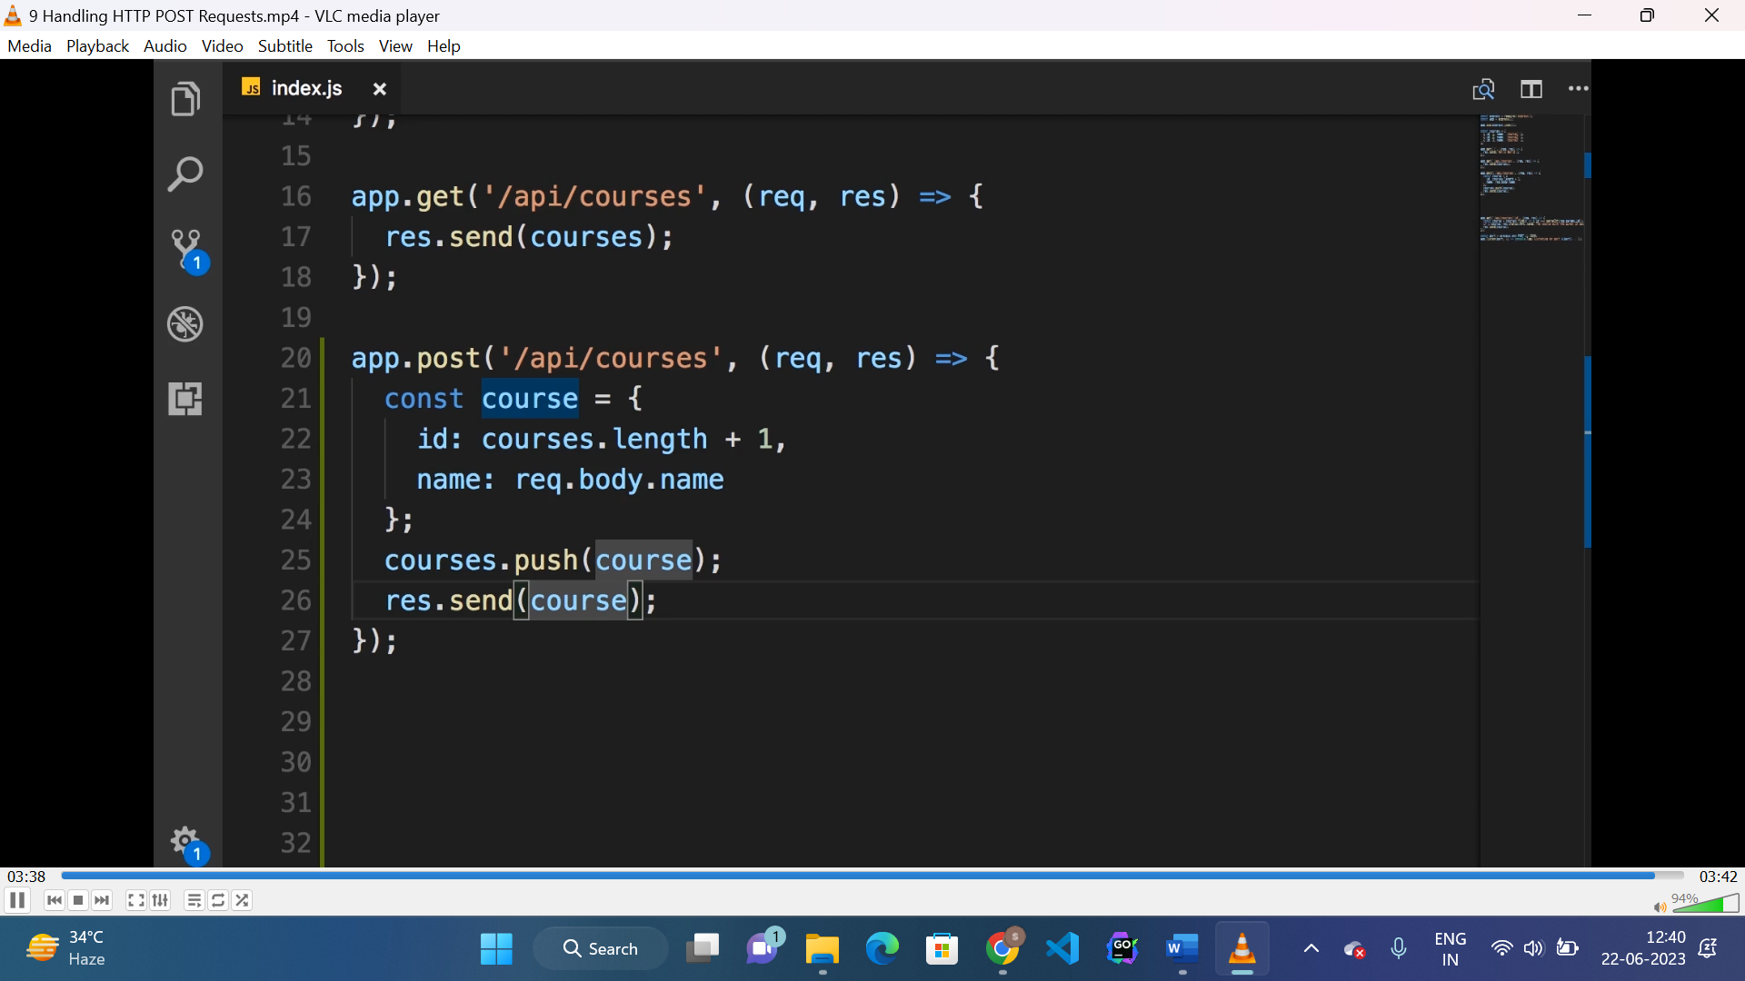

* To convert response body from json to object “express.json()” middleware is used.

**PUT request:**

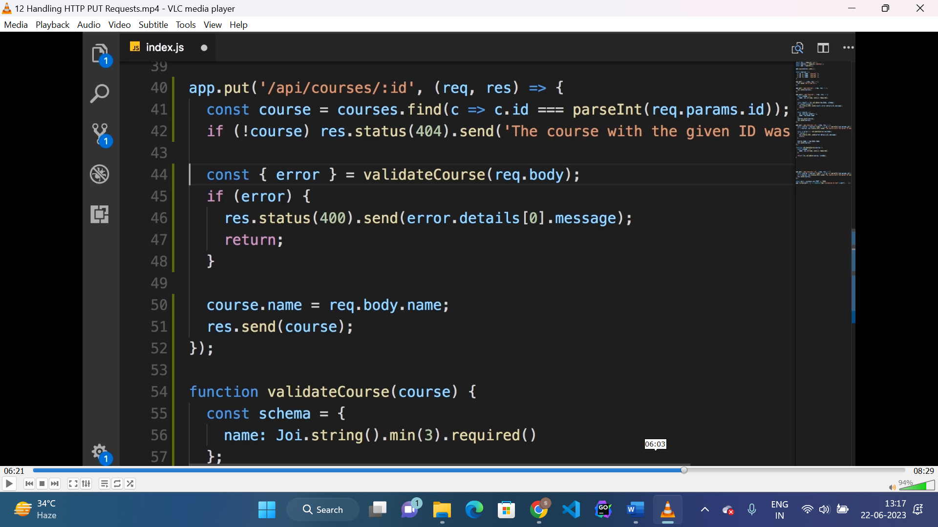

Steps:

* Check for id of course, if not exist return error.
* Validate the course object.
* Update course in database.

**DELETE request:**

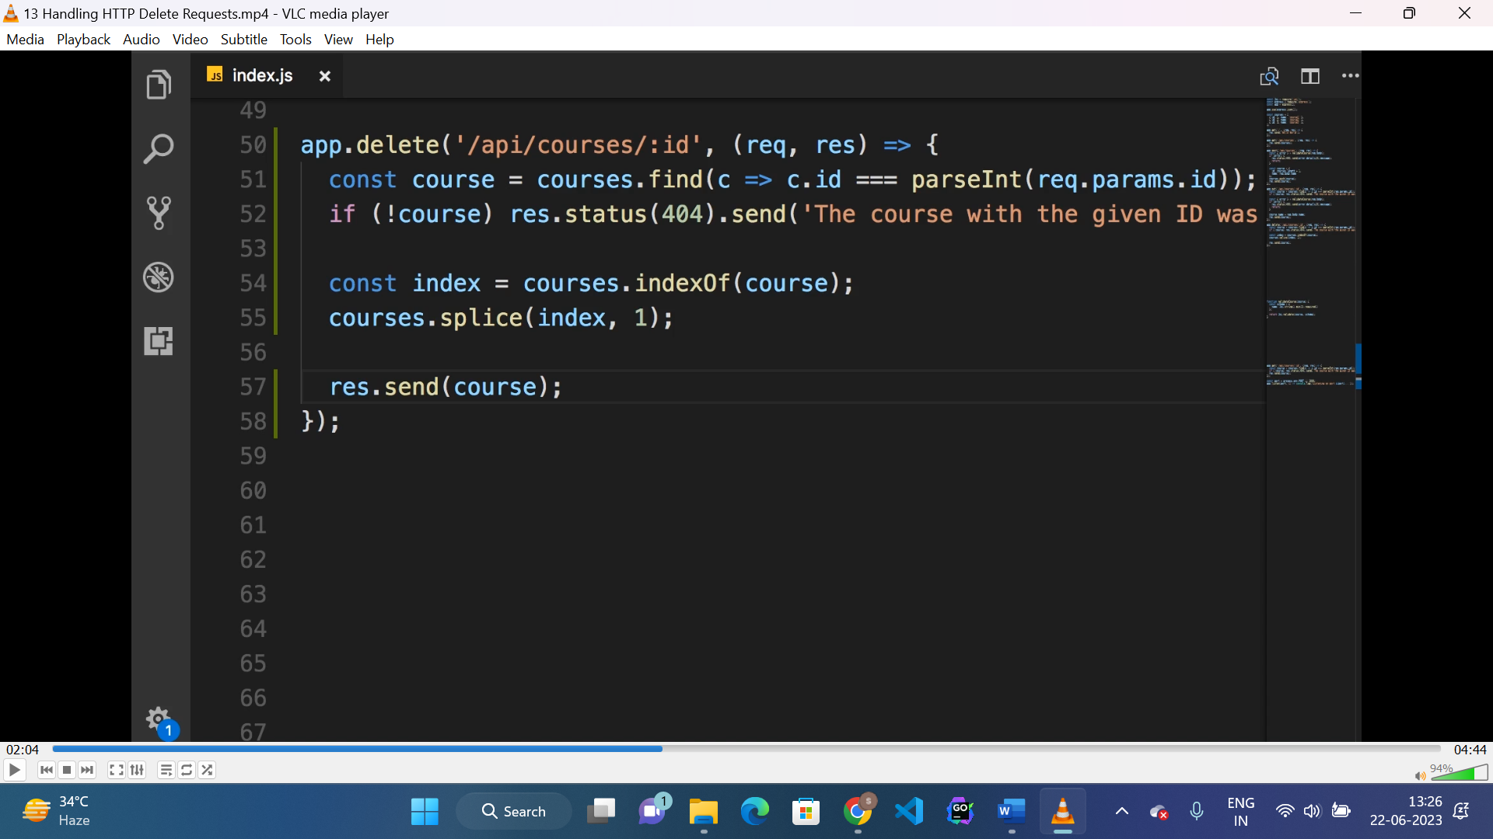

* Find course by id, if exist find index then delete from array.

**Middleware:**

* A middleware is a function that intercepts the request before it reaches to the route handler.
* Here “next()” method is used to pass the “request” and “response” to next middleware or route handler.

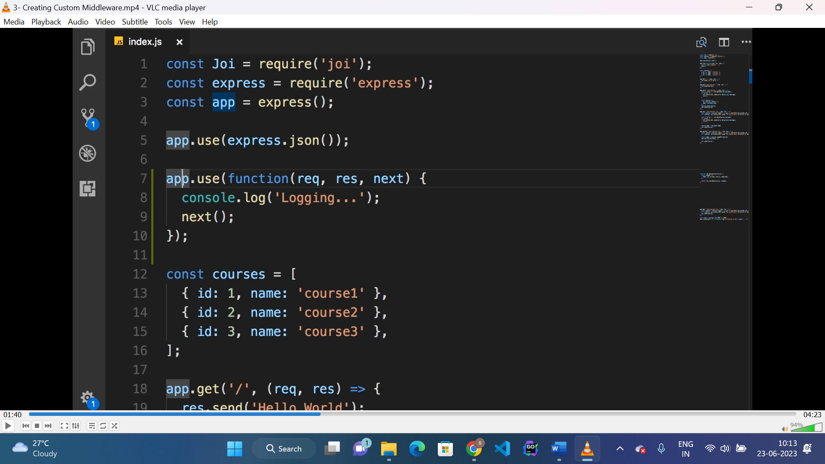

Built-in middlewares:

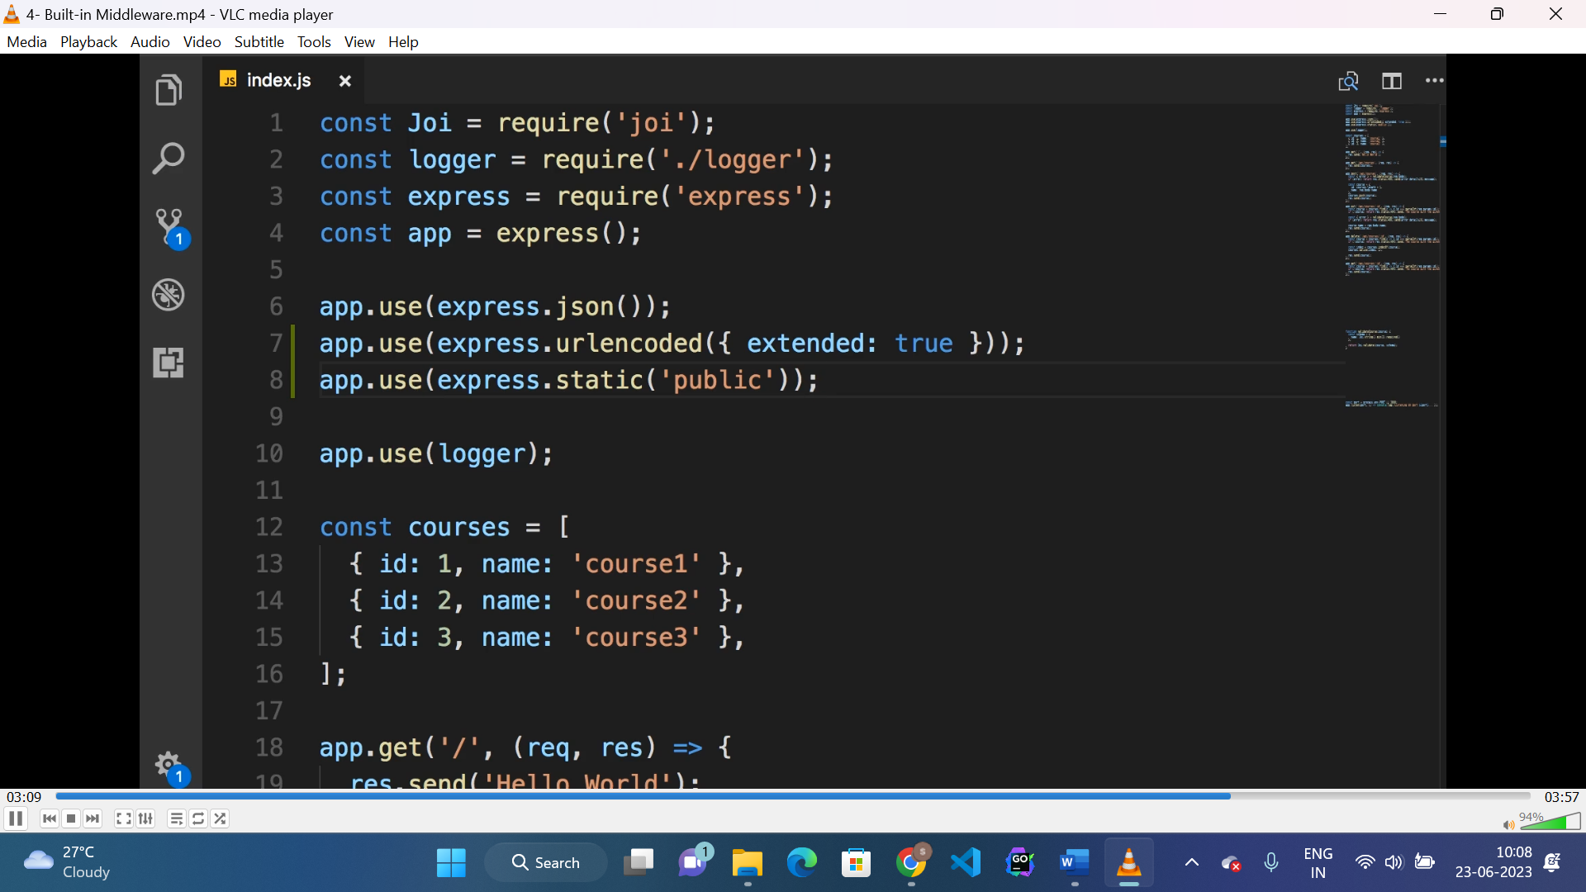

* “urlencoded({extended:true})” is used to encode complex data from URL and decode it to “req.body”.

3rd party middleware:

* **Morgan:** used to log every request to the server.
* **Helmet:** used to add various header to the request for securing application.

**Enabling logging only on develop:**

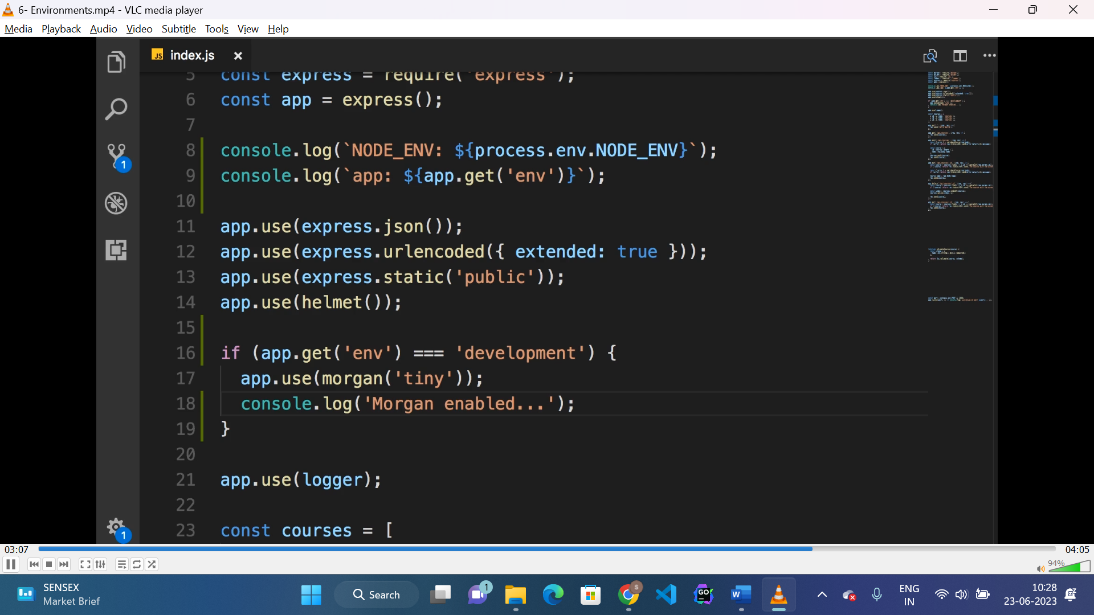

* Here “app.get(“env”)” returns “dev”, “sit” or “prod”.
* If it returns “dev” then only morgan will be enabled.

**Configuration(config package):**

* To store configuration of application “config” package is used.

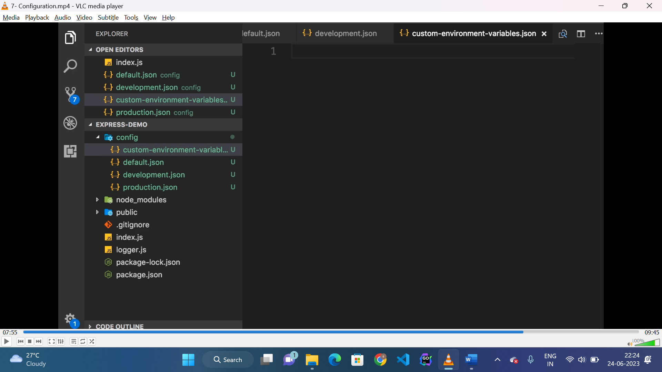

* To store config above folder structure of JSON files is created with same name for different environments.

Dufualt.json:

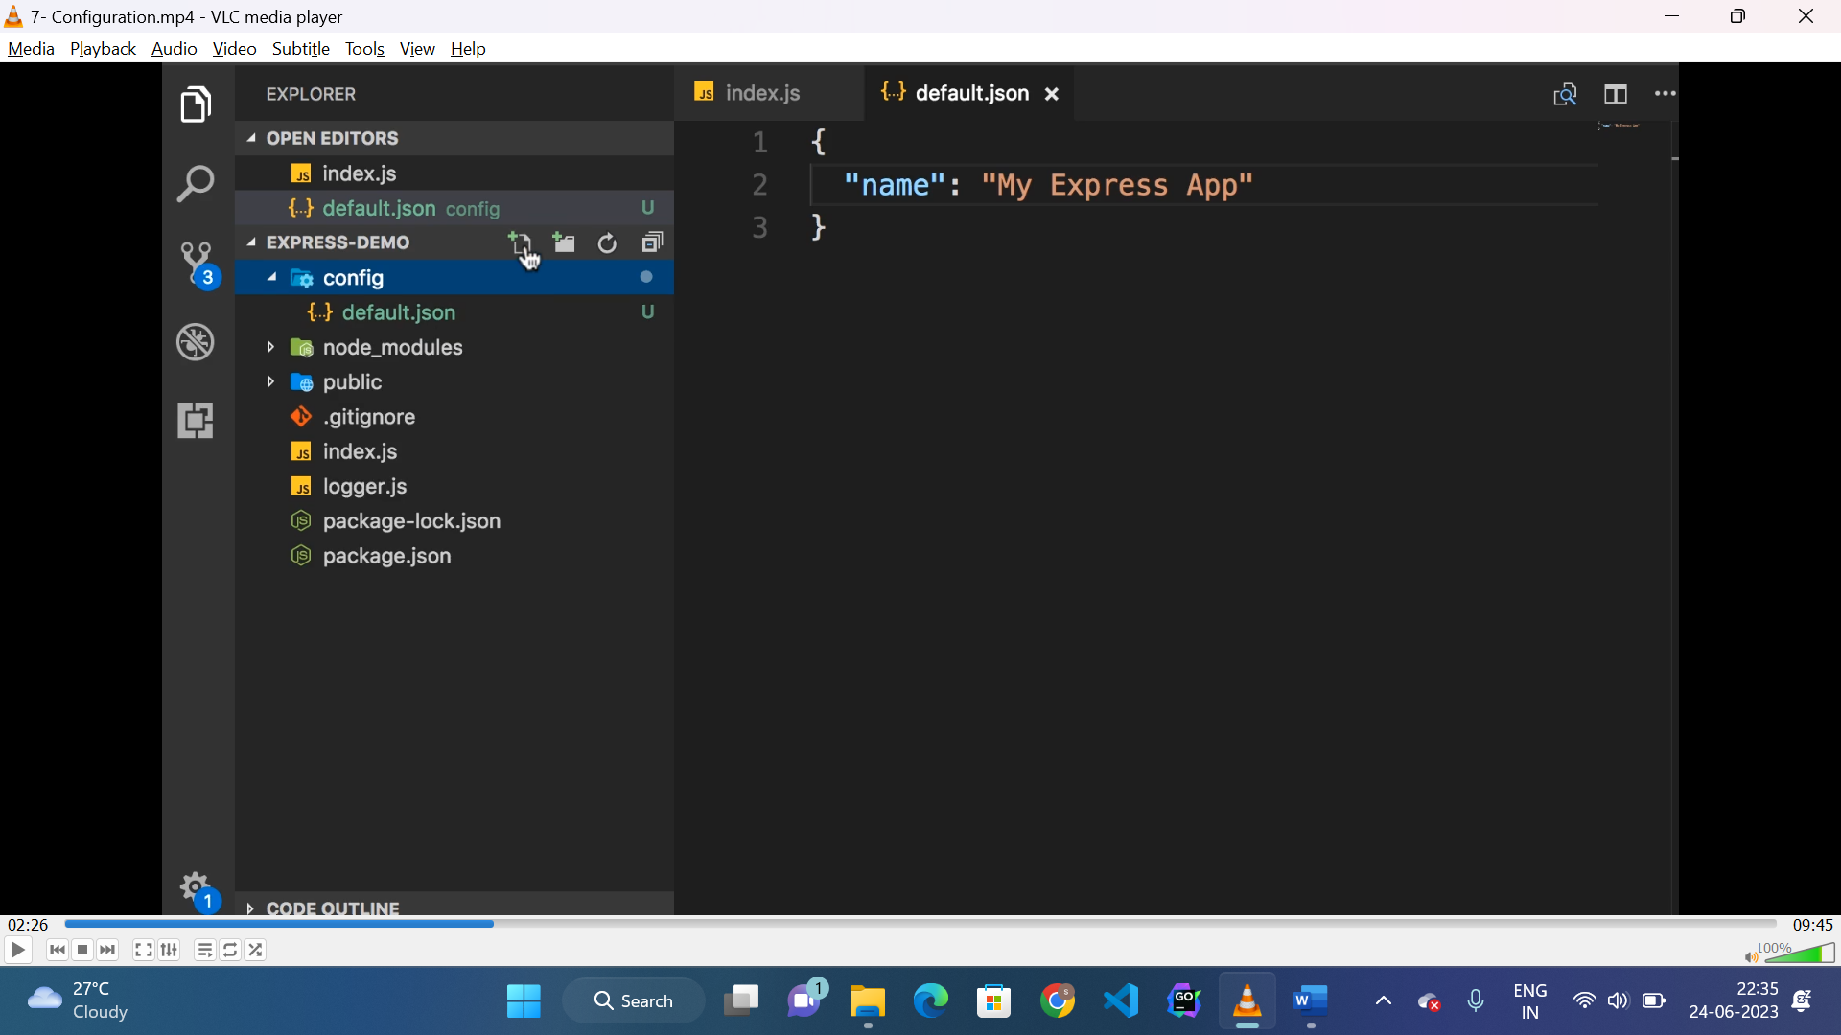

Development.json:

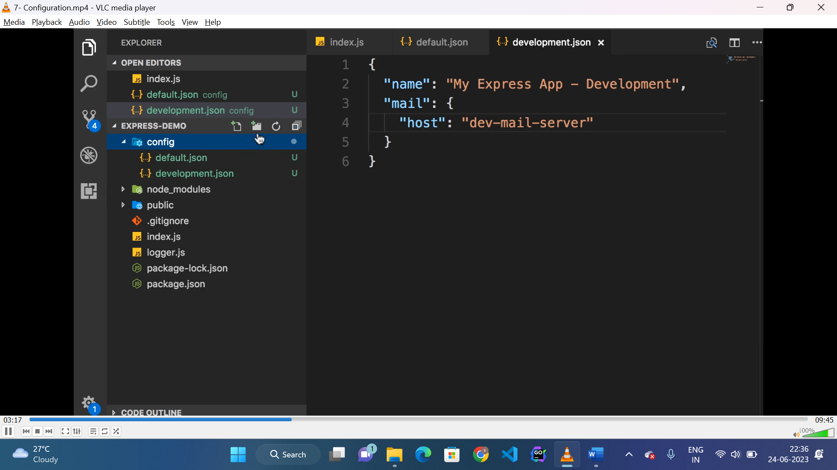

Production.json:

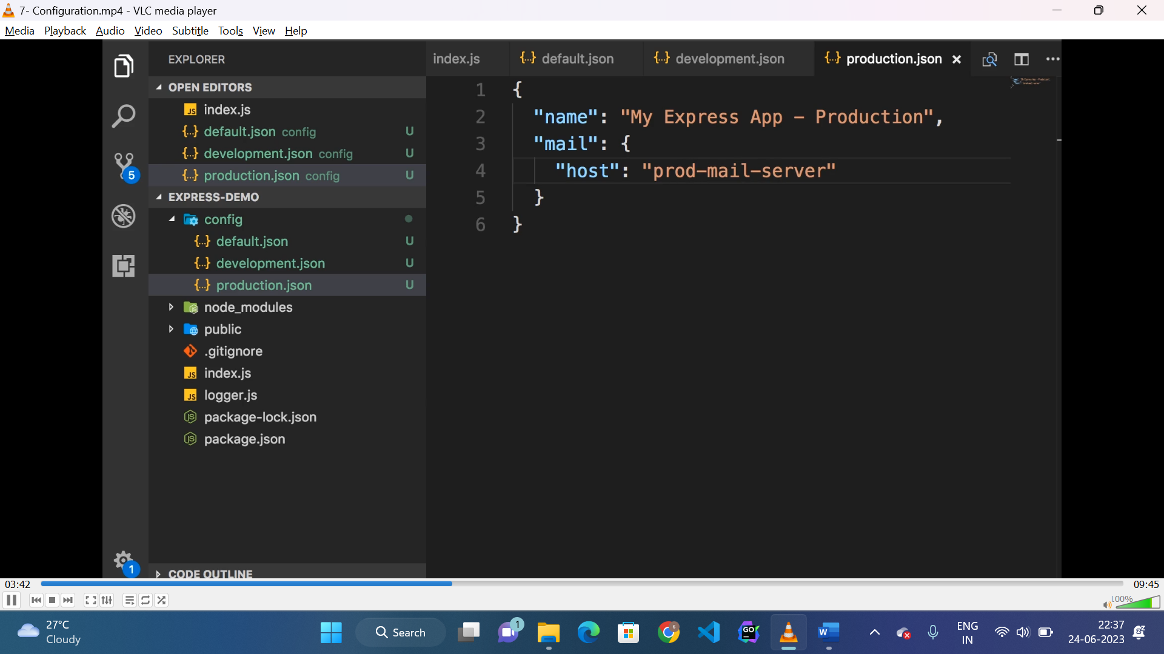

Mapping environmentvariable to config:

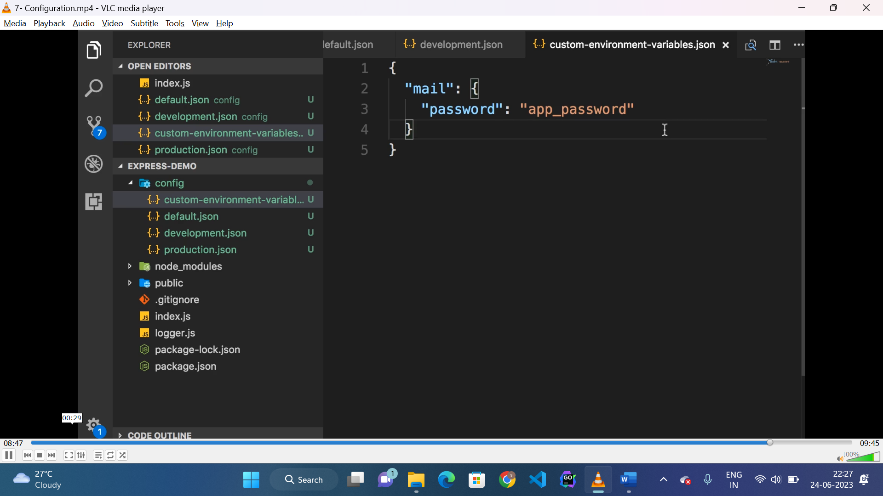

* Here “app_password” is a environment variable which is mapped to password(mail.password) field in config files.
* To access the values from the configuration “config.get(property)” is used which check the value from config files or environment or commandline.

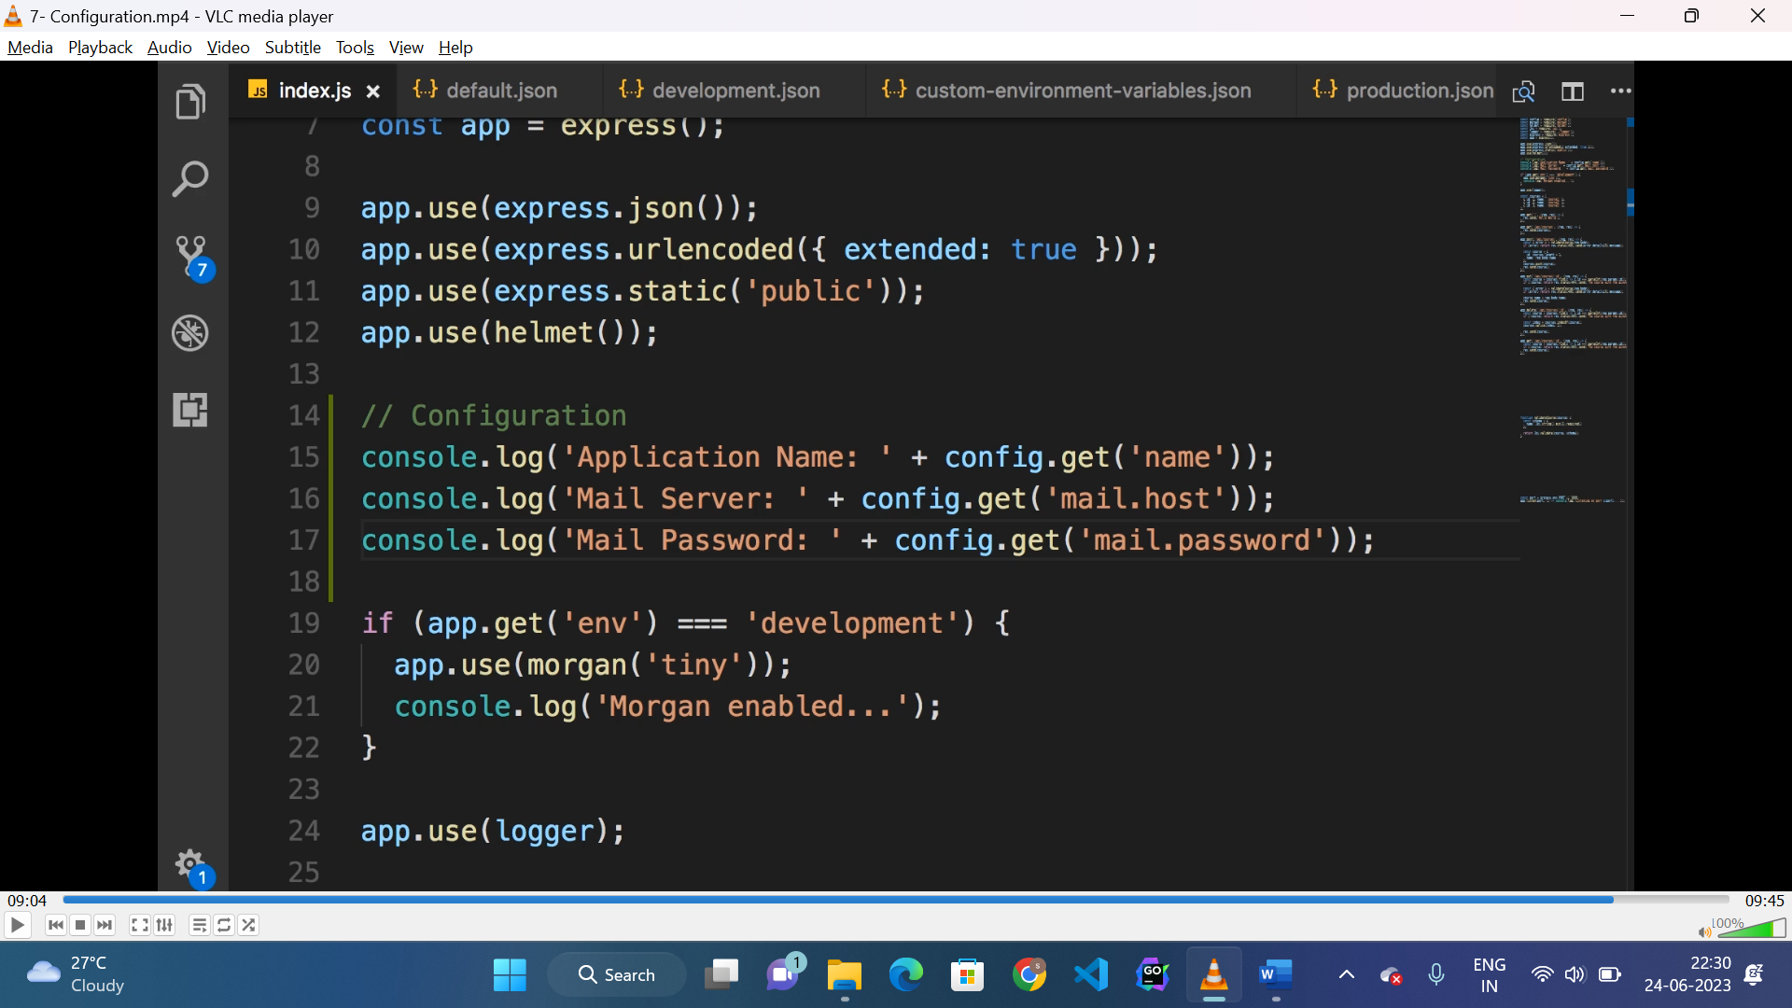

**Creating custom router:**

* To create separate router for separate routes, “express.Router()” is called.
* After creating routes, export the router to be used in “index.js”.

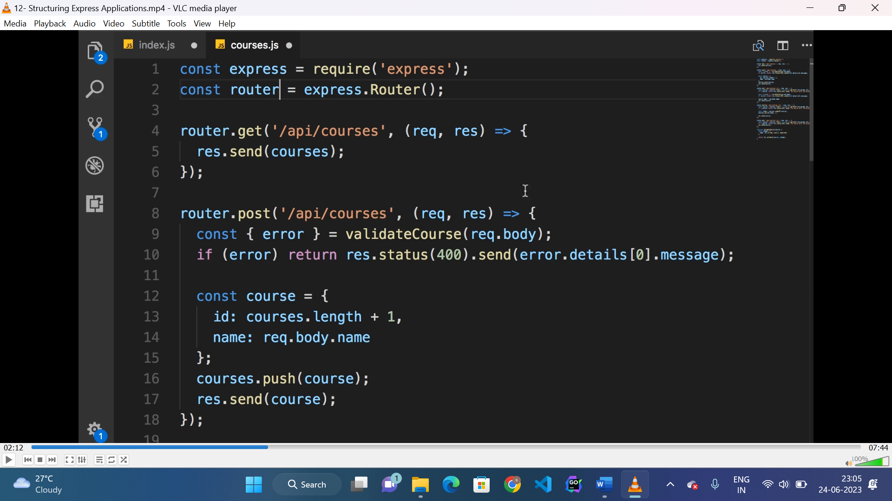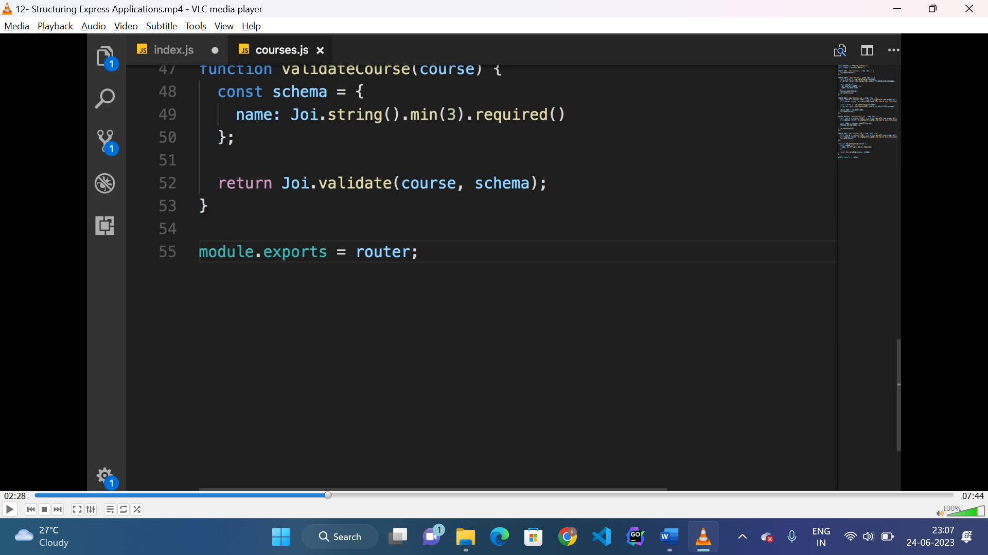

* The same route can be imported and used in index.js file in our application.

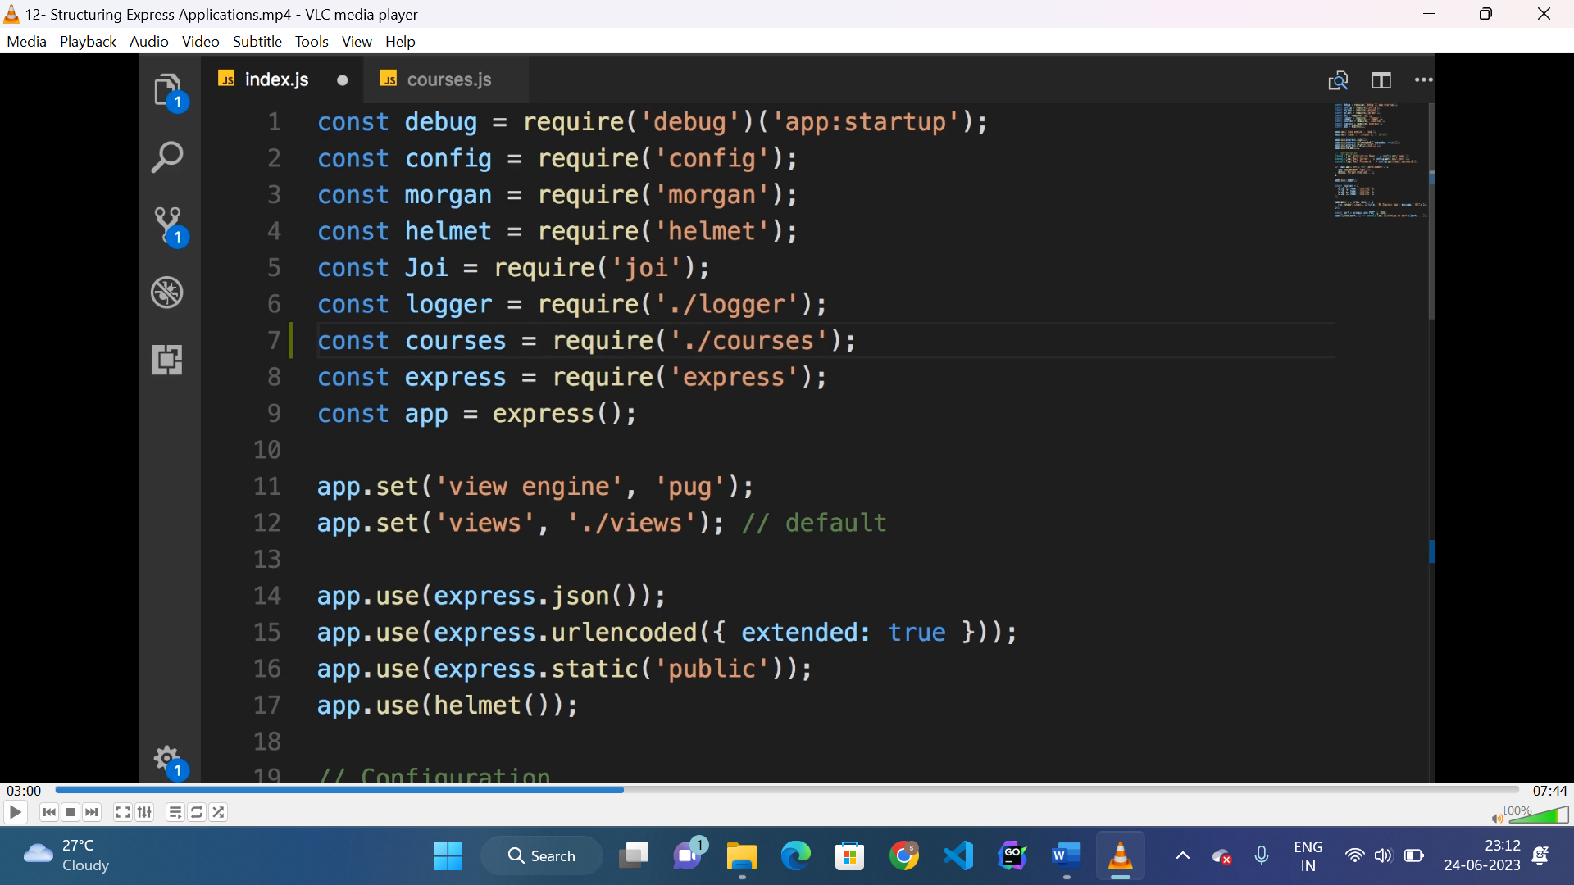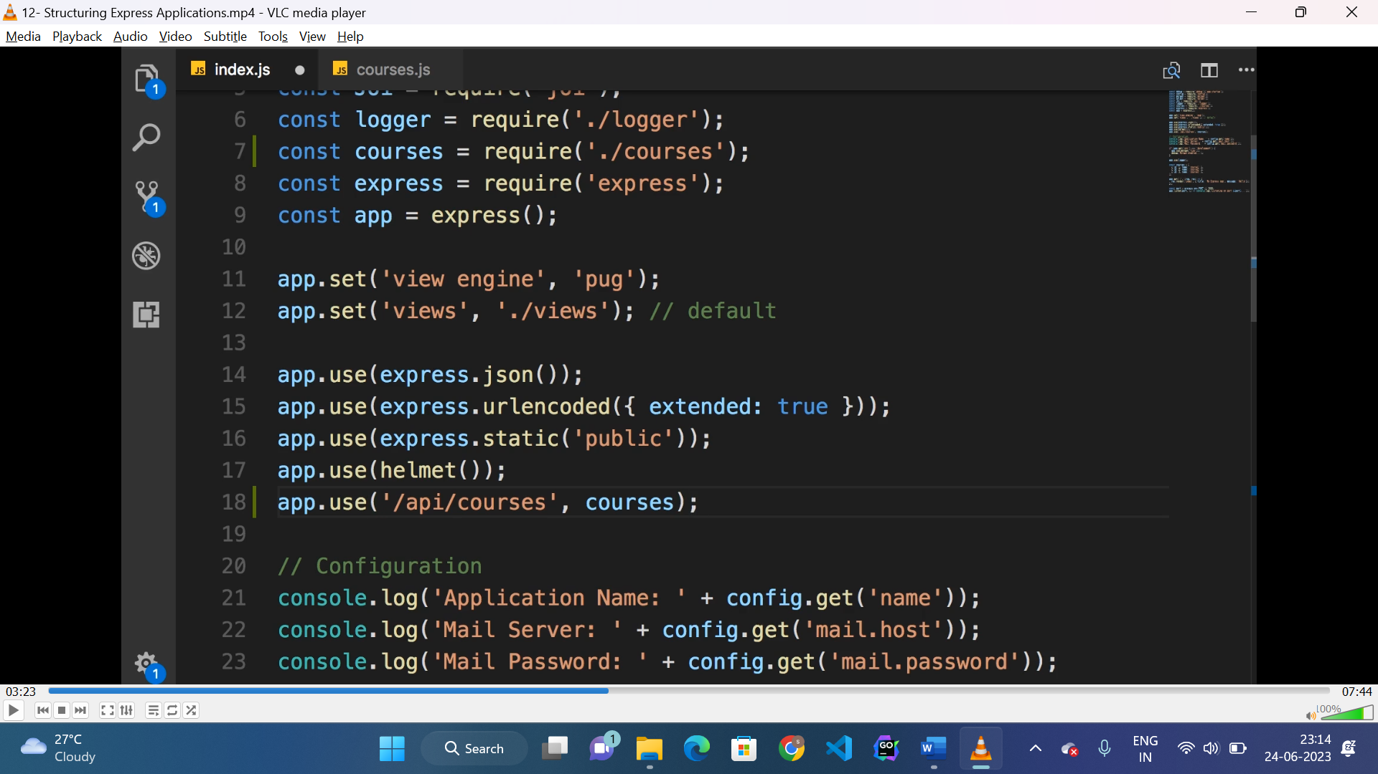

* Here any route starts with “/api/courses” will use “course” router.
* The same way middlewares can also be exported and used.

**Handling ASYNC code using callback:**

* We can generate a async code using “setTimeout()”, which takes a callback which executes after the given time period.
* But to execute the call we need to pass a callback to the into “setTimeout()”.

Steps:

* Create a “setTimeout()” function.
* Wrap that into a function.
* Pass a callback into that function , which will return or execute the value which the 1st argument of “setTimeout()” does.

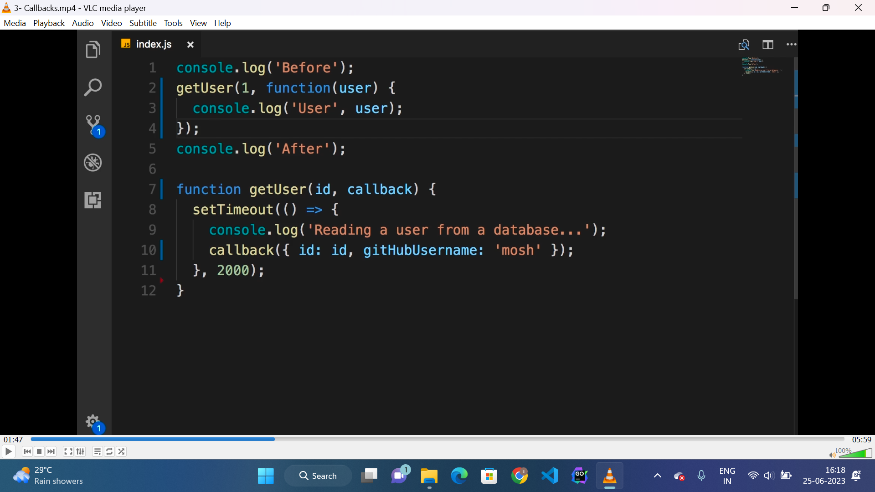

**Promise:**

* A promise is a JS object that holds the eventual result of asynchronous operation.
* It has two state “resolve” and “reject”.
* On “result” resolve() method will execute and on error reject() method will run.
* Promise can have two chaining methods called “.then()” and “.catch()”.

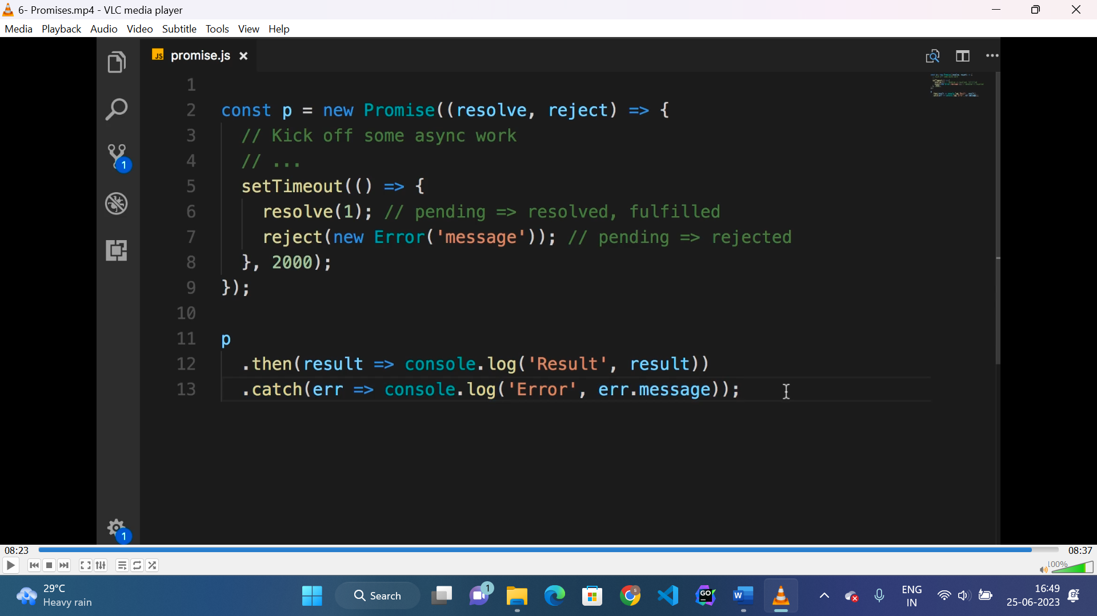

**Handling resolved promise:**

* If promise is already resolved then we can handle that using the following way.

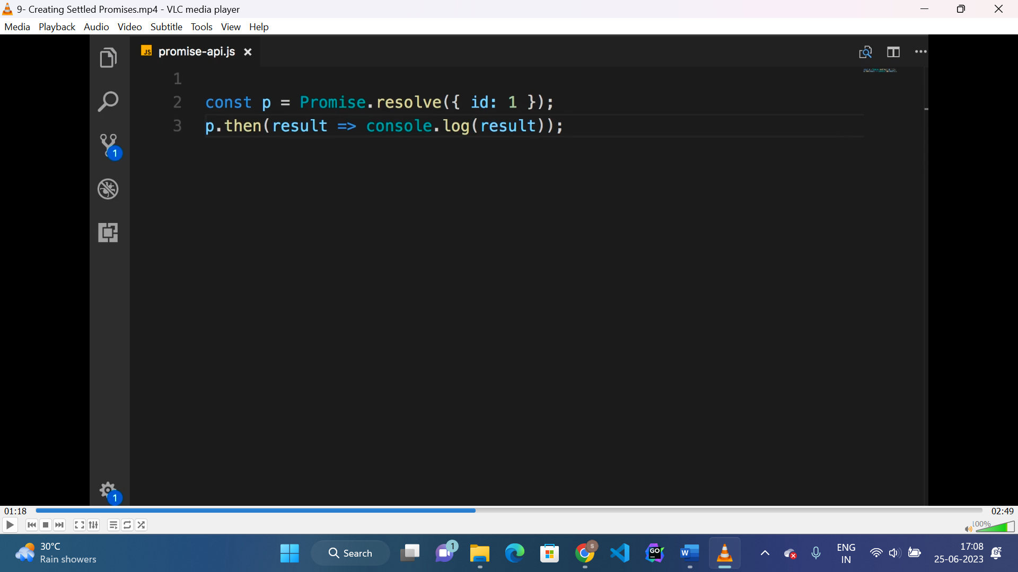

* Similar way we can handle already rejected promise.

**Parallel promise:**

* To execute promises in parallel “promise.all([])” is used which takes a array of promises.
* It will return a new promise if all promises run successfully otherwise “rejected”.
* It can be handled using “.then()” and “.catch()” method.
* If we want to resolve the promise even one promise executes successfully then, “promise.rece([])” is used.

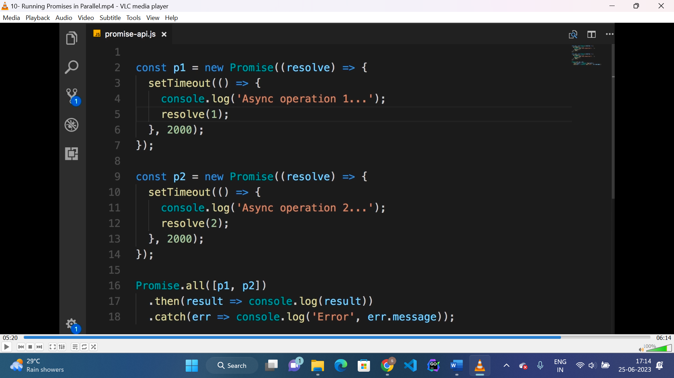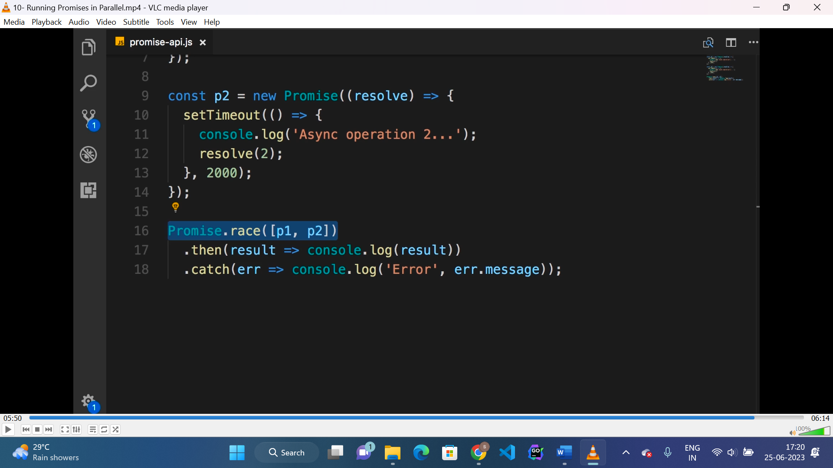

**Async and await:**

* Async and await are syntactical sugar over promise.
* “await” is used before a asynchronous operation and the method executes “asynchronous” operation should be decorated with “async” .

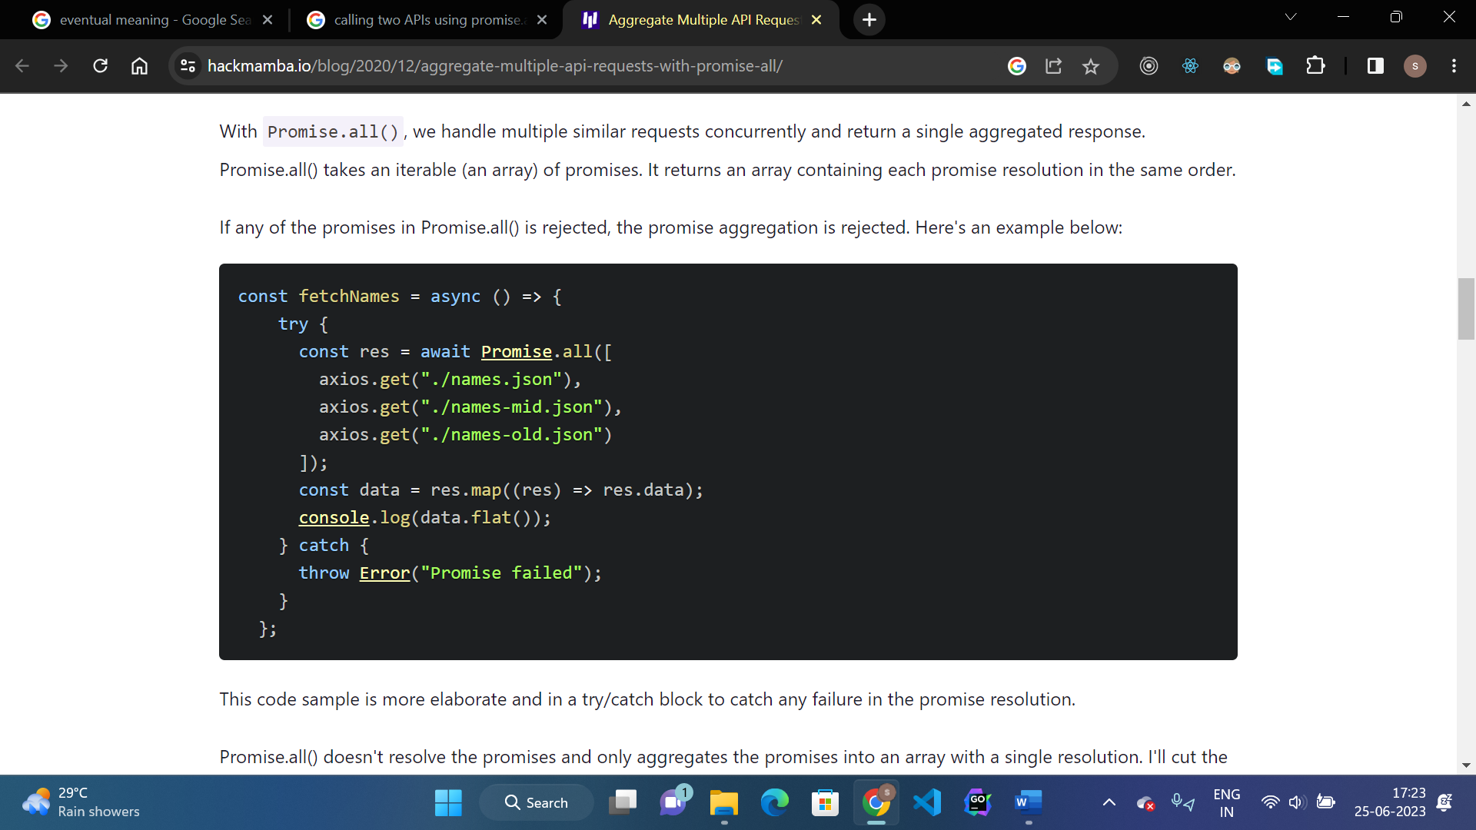

* For async and await instead of “.then()” and “.catch()” try() and catch() is used.

**Mongoose CRUD:**

* To connect to mongoDB database “mongoose” package is used.

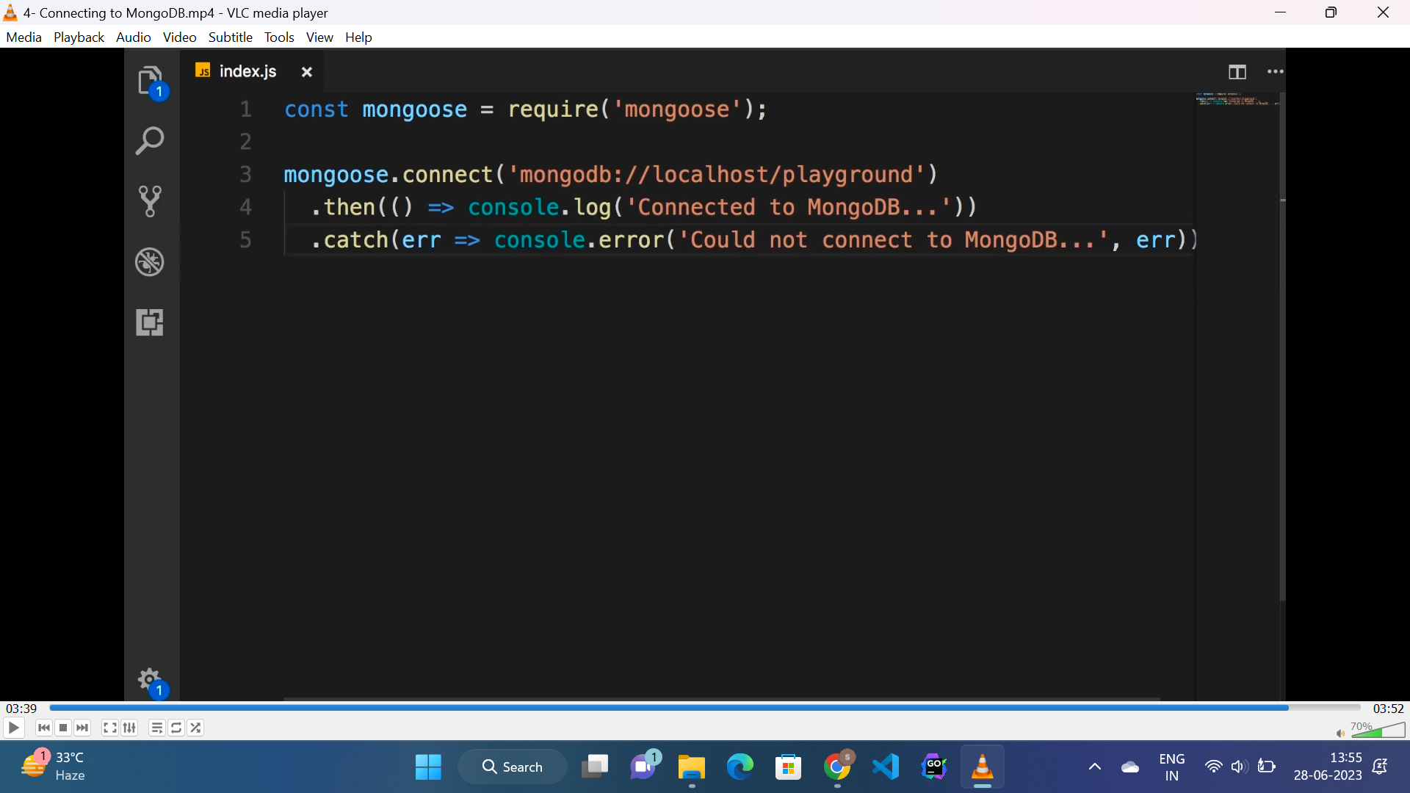

* Here “connect()” returns a promise.

**Schemas:**

* Schemas are used to define the structure of documents(data) for a collection.
* Supported data types for mongodb to be added in schema are mentioned below.

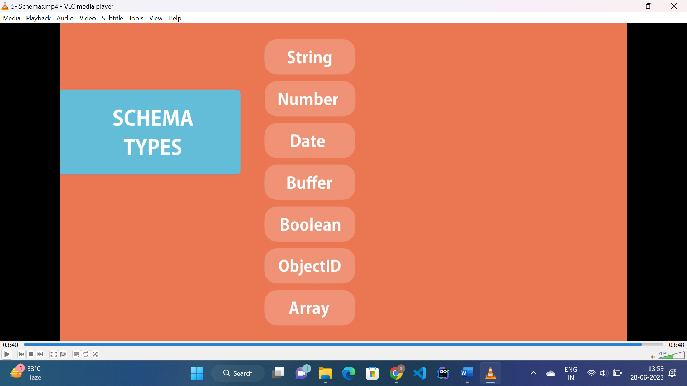

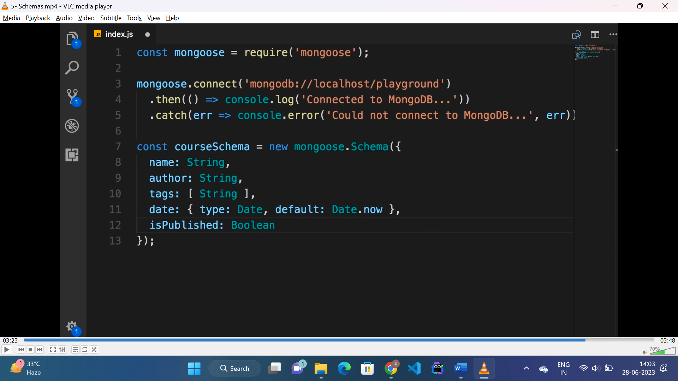

**Model:**

* A model class in mongodb is compiled from a schema and collection name.
* Then we create a object from that class which maps to a document in mongodb database.

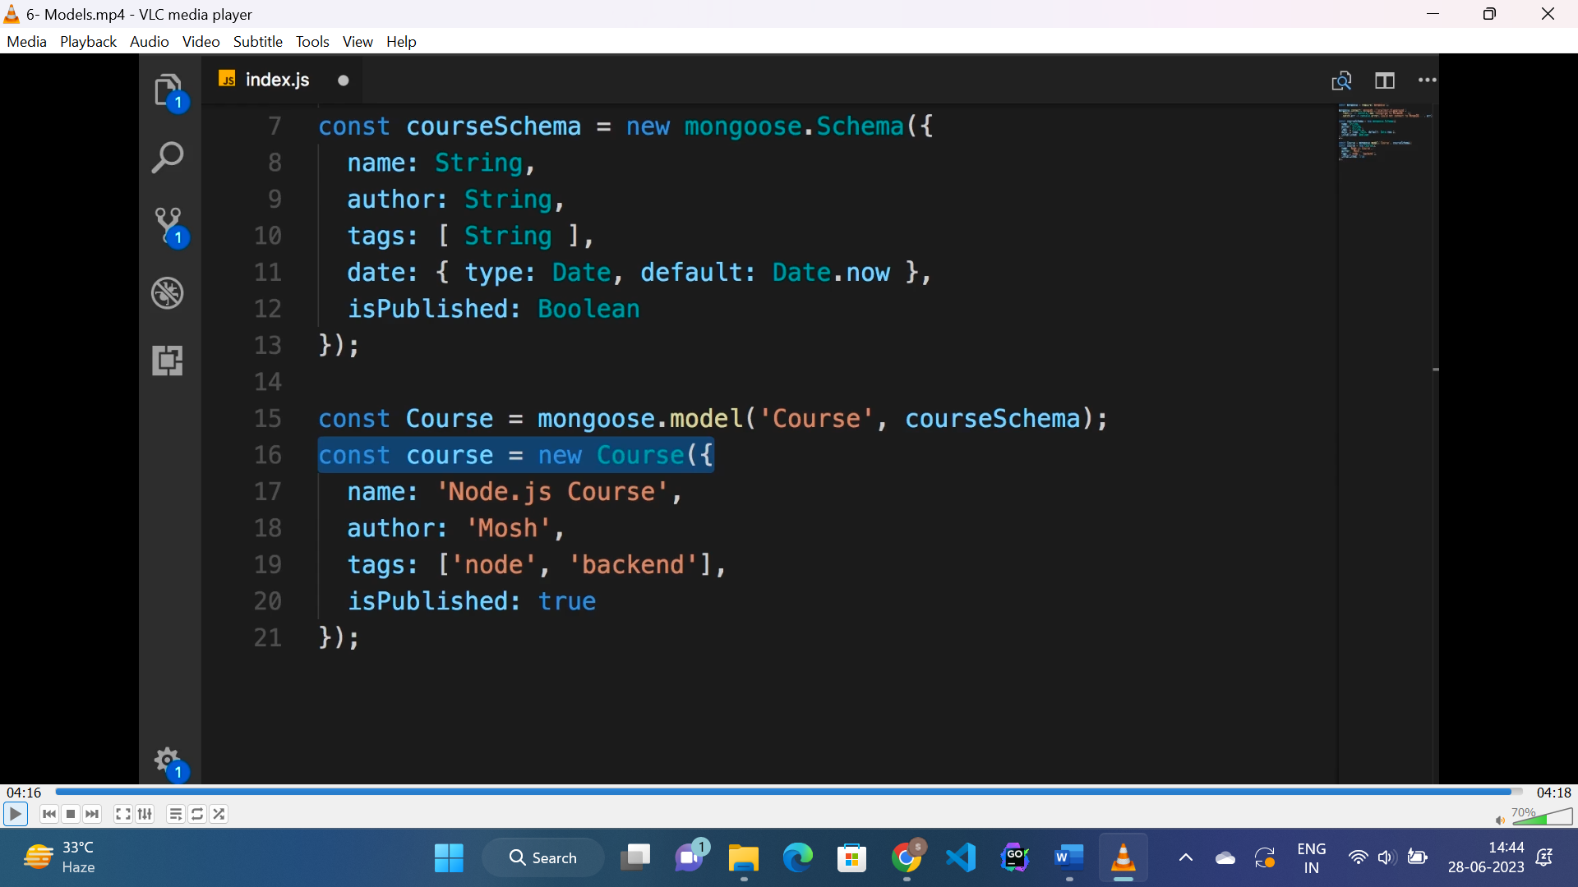

* Here “Course” is collection name.

**Create a course:**

* To create a course we need to call the “save()” method from the object created from “model” and it is a asynchronous operation.

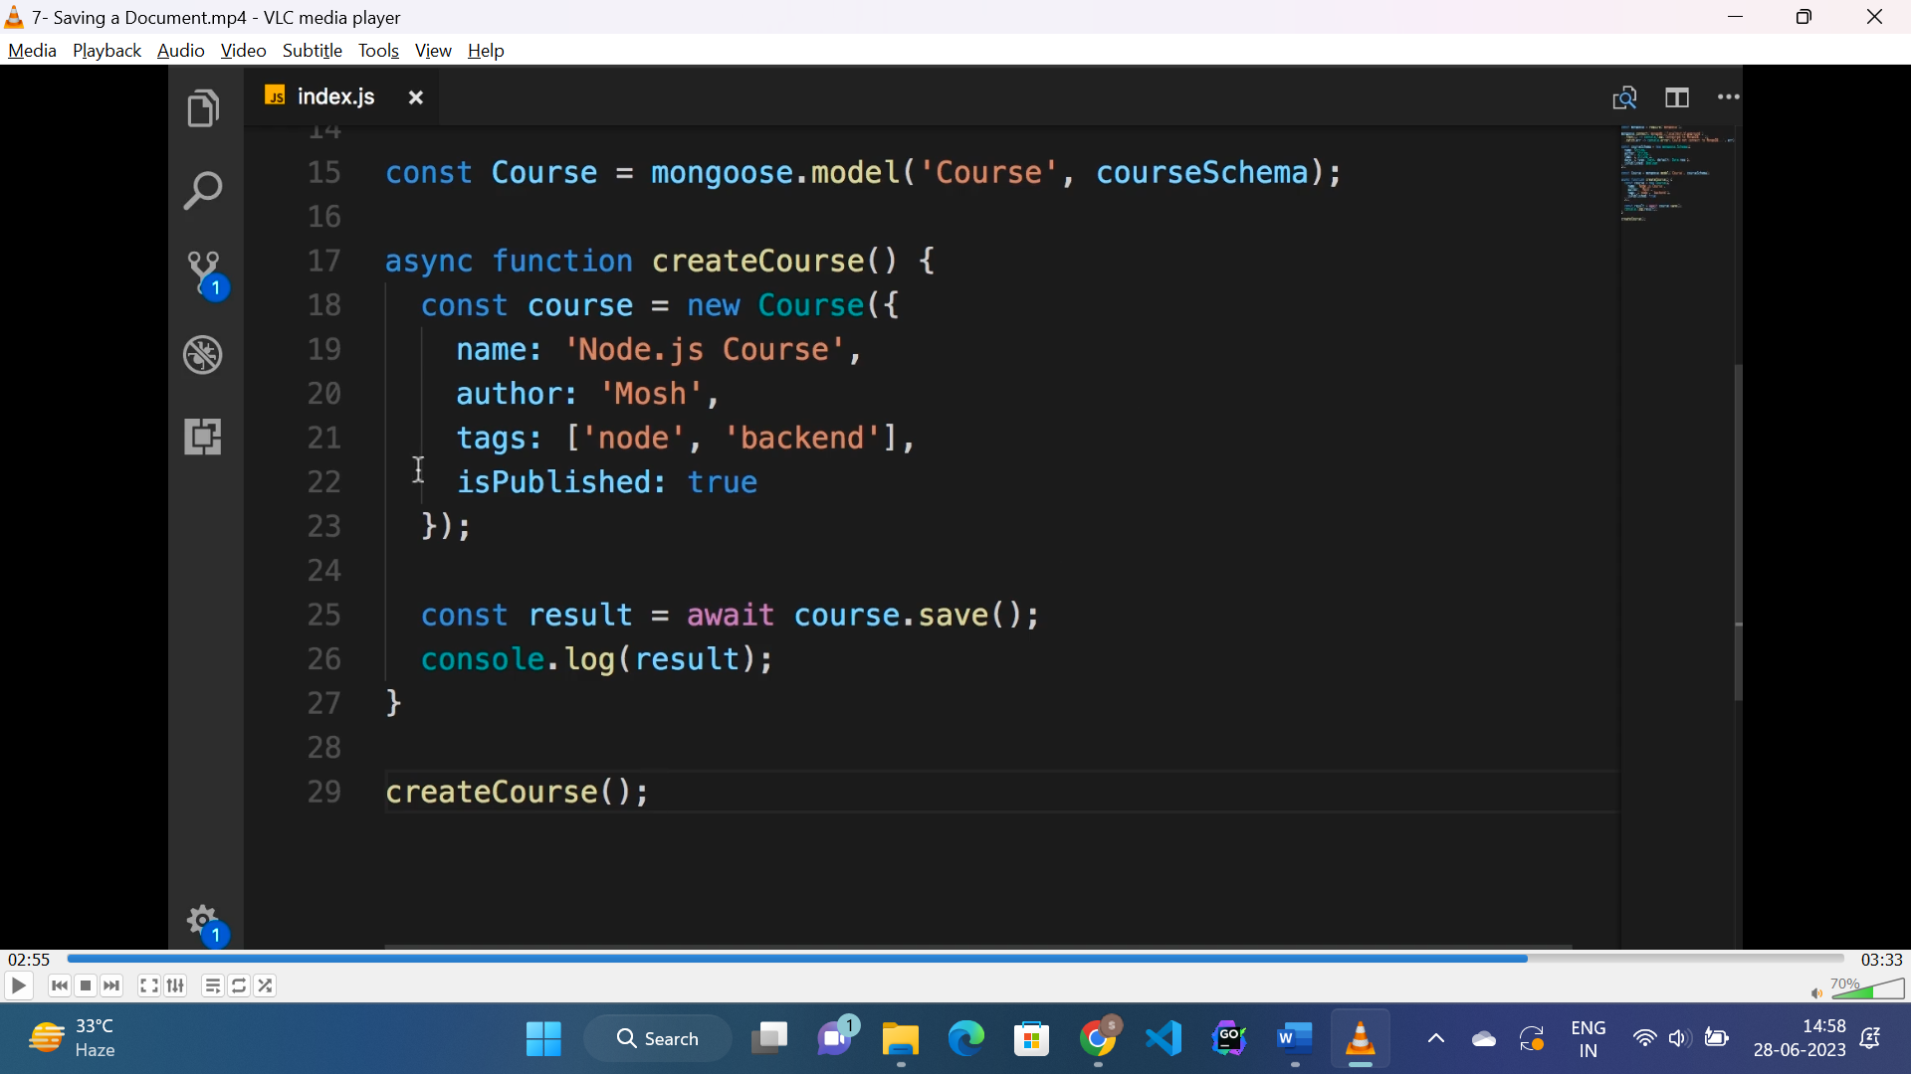

* As a result we will get the same course with a “_id” assigned to it.

**Getting data from mongoDB:**

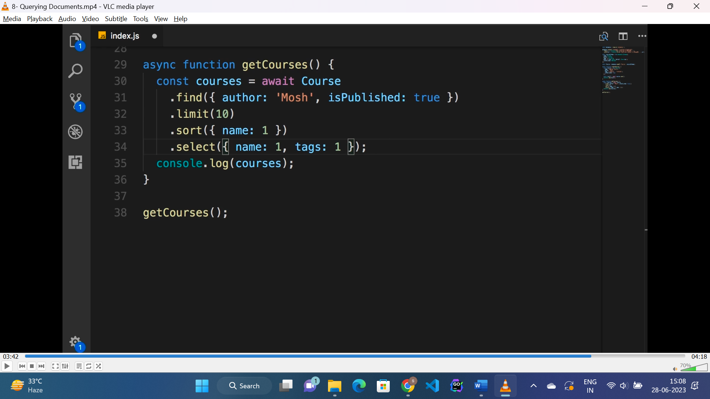

* The Course model class has some methods to get filtered data from db. Some of them are shown above.
* “find()” method filters documents with author “mosh” and published to “true”.
* “limit()” method limits to “10” documents to be shown.
* “sort()” method sorts data by “name” as given to sort in descending order value should be “-1”.
* “select()” method selects only the “name” and “tags” field of all documents and rest all are skipped.

**Comparision operator:**

* In mongoose the available comparison operators are :

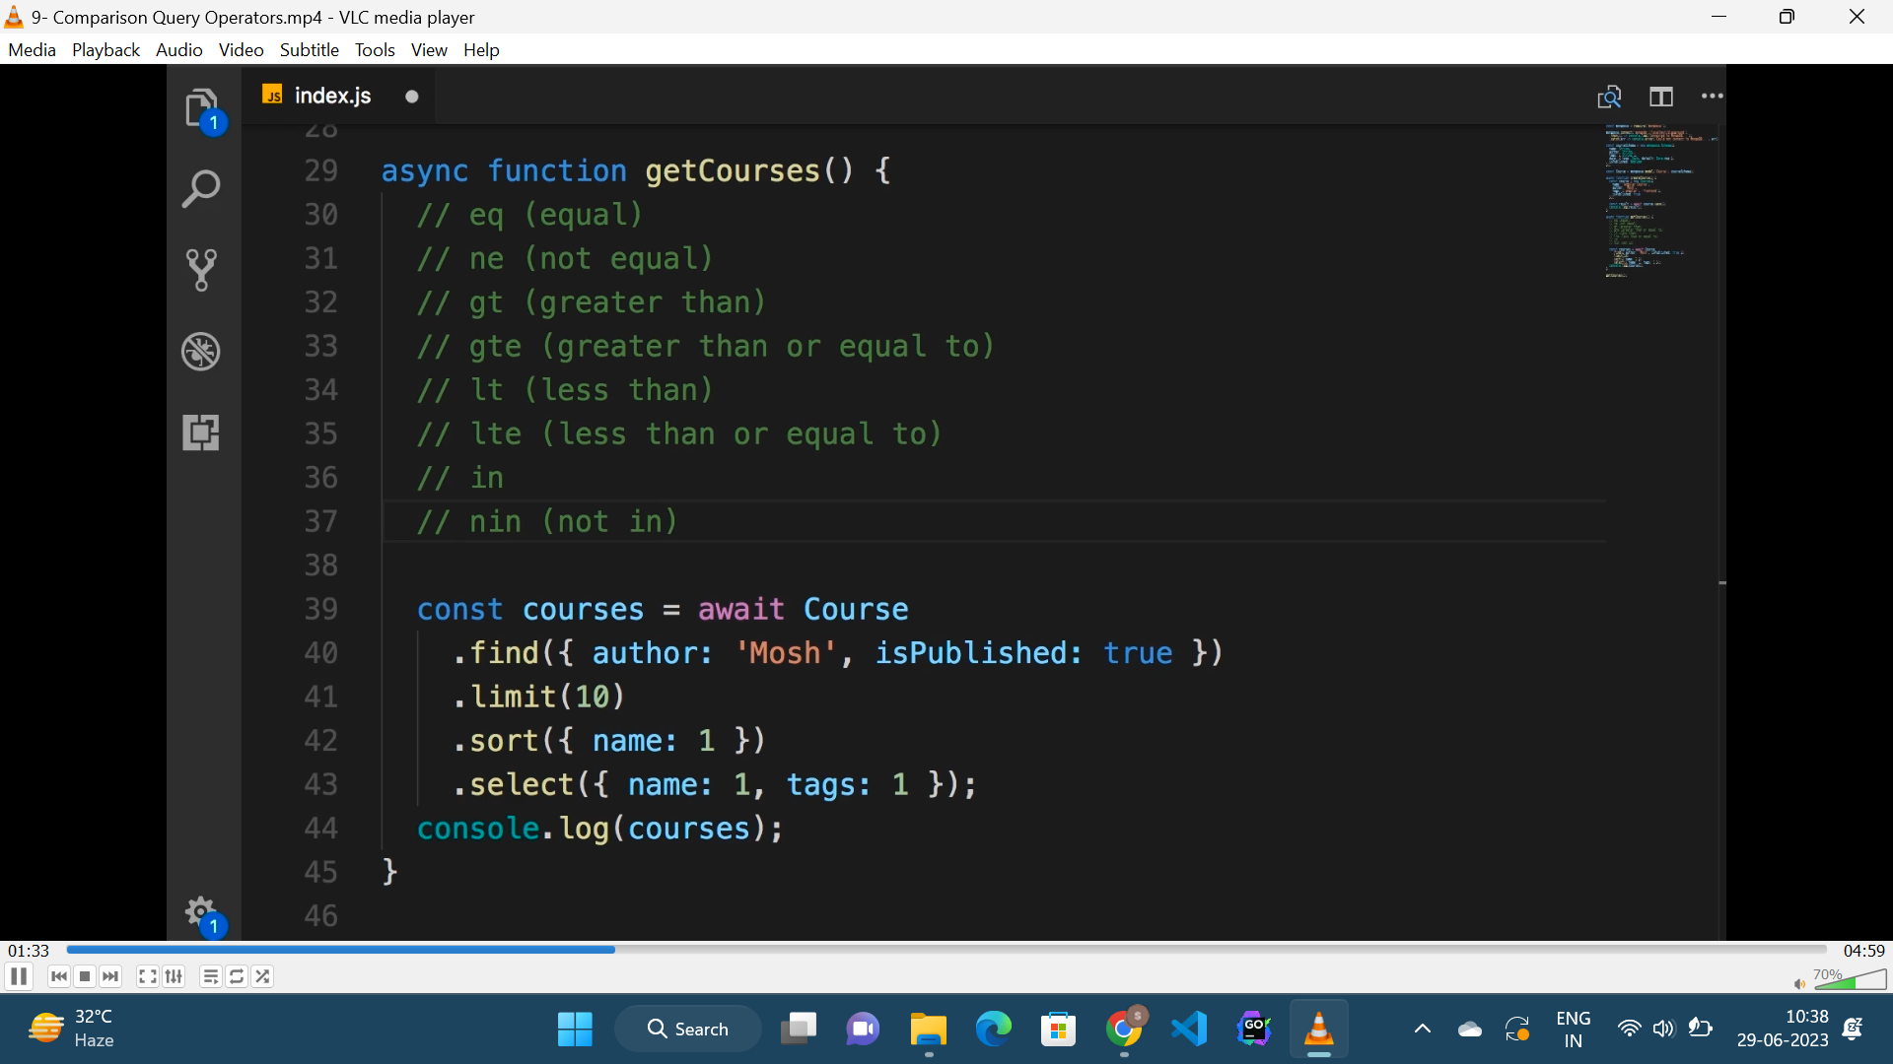

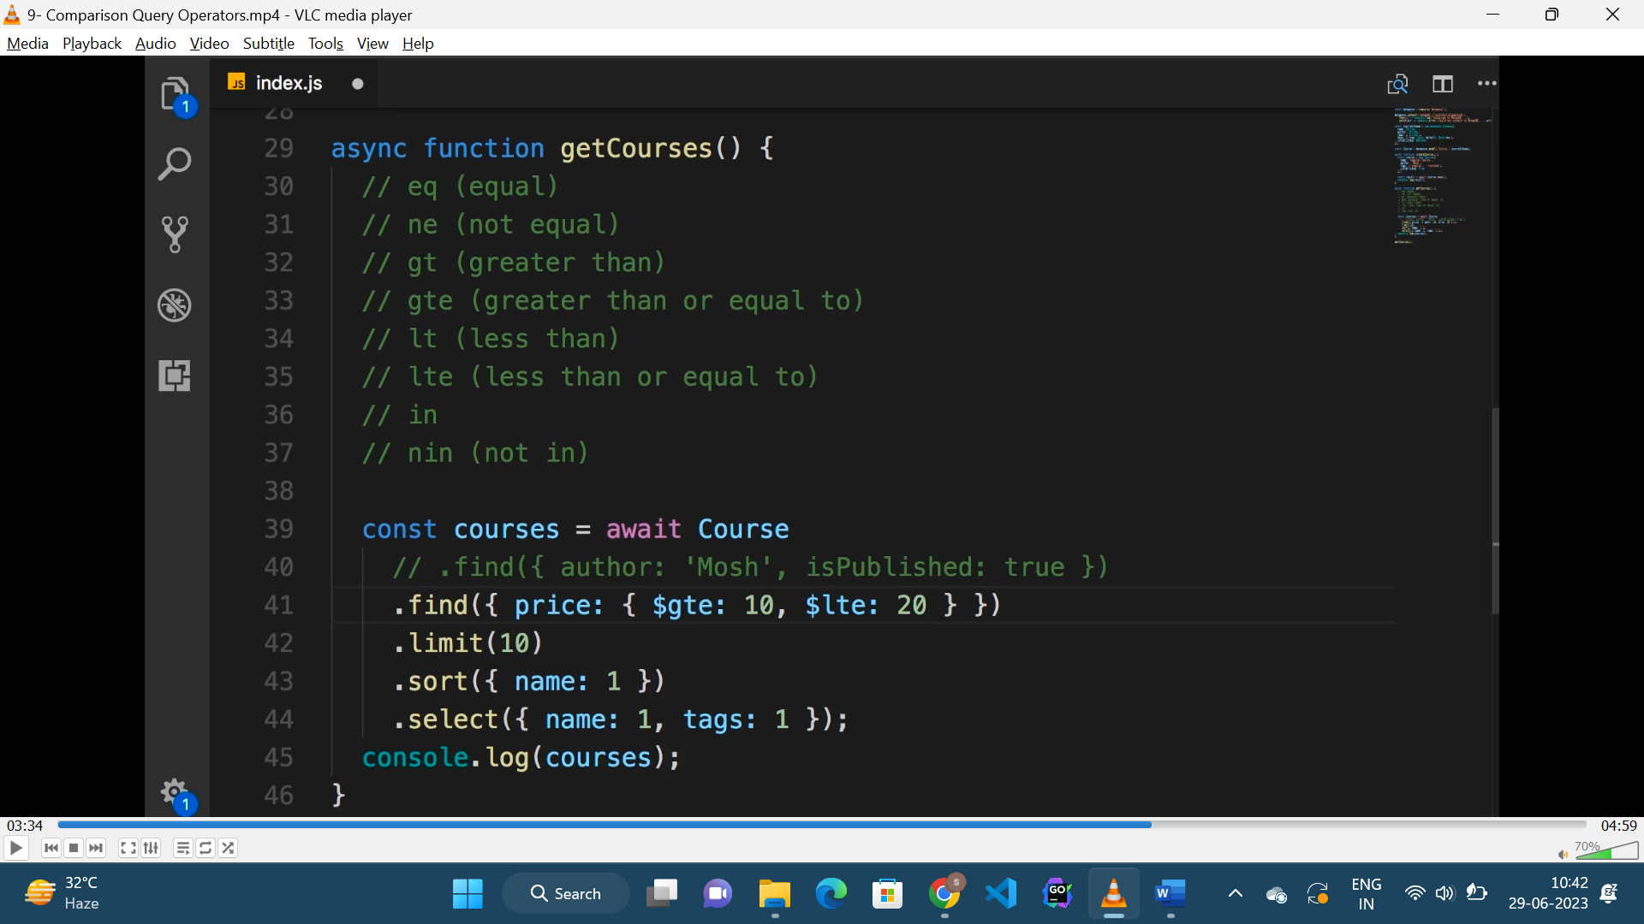

* Here price should be grater then “10” and less then “20”.

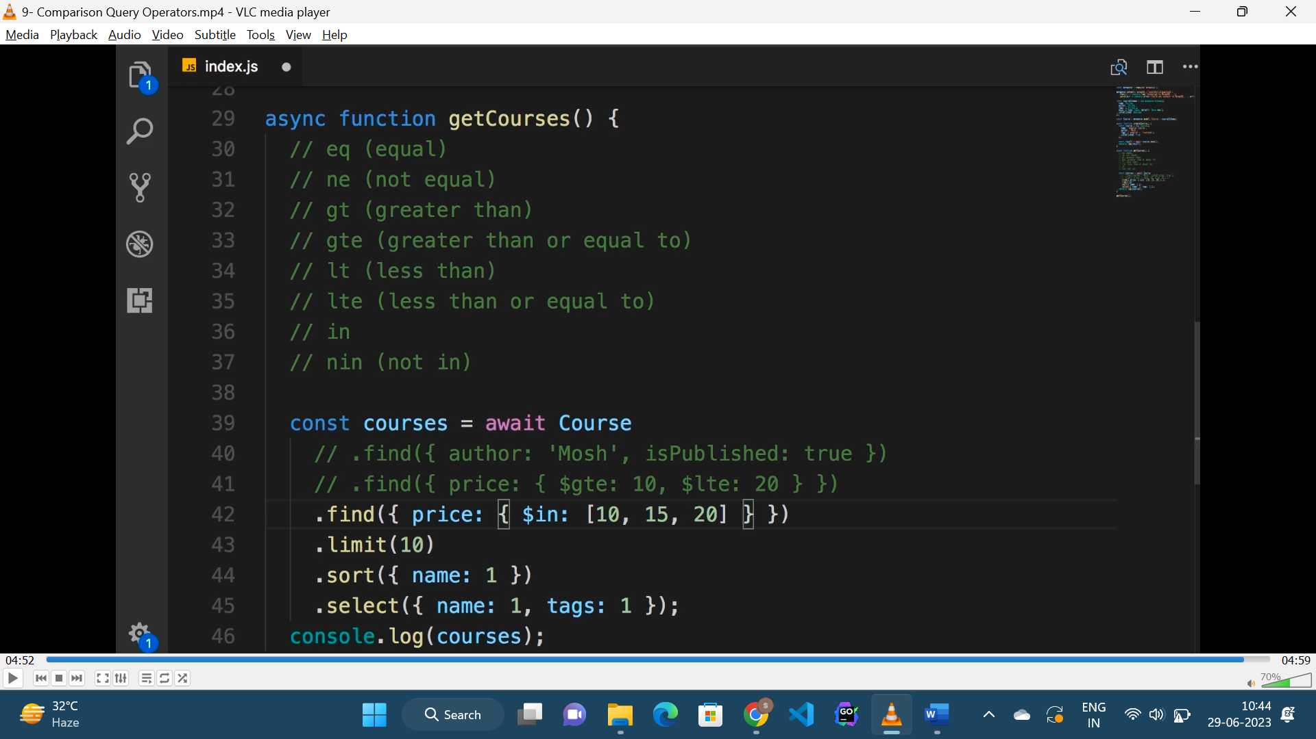

* Here price should be either “10” or “15” or “20”.
* The similar way all the comparison operator work.

**Logical “and”, “or” operator:**

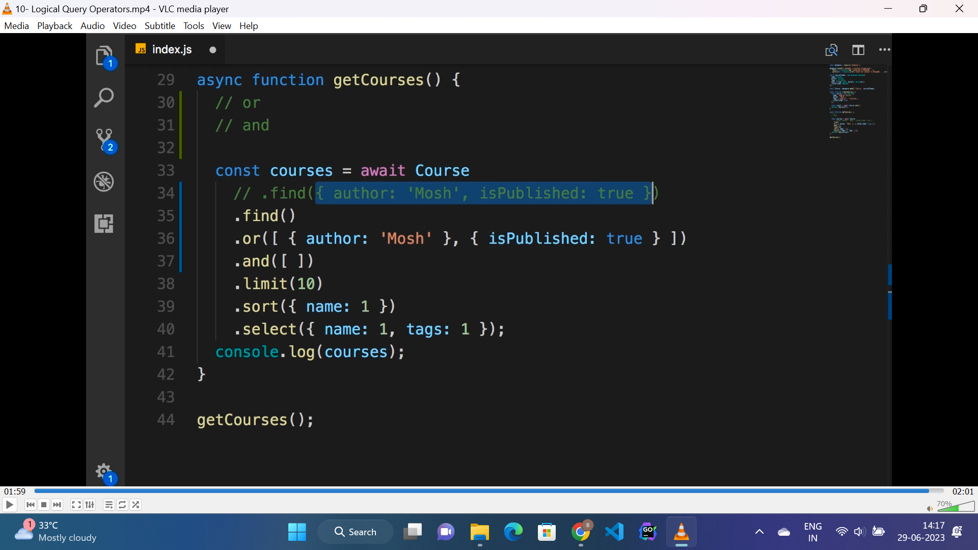

* Instead of adding filter in “find()” method, add “or()” method with array of two objects, i.e : either author “mosh” or published.
* “and()” method is similar to “or()” method.

**Regular expression:**

* Regular expression can be used while filtering data.

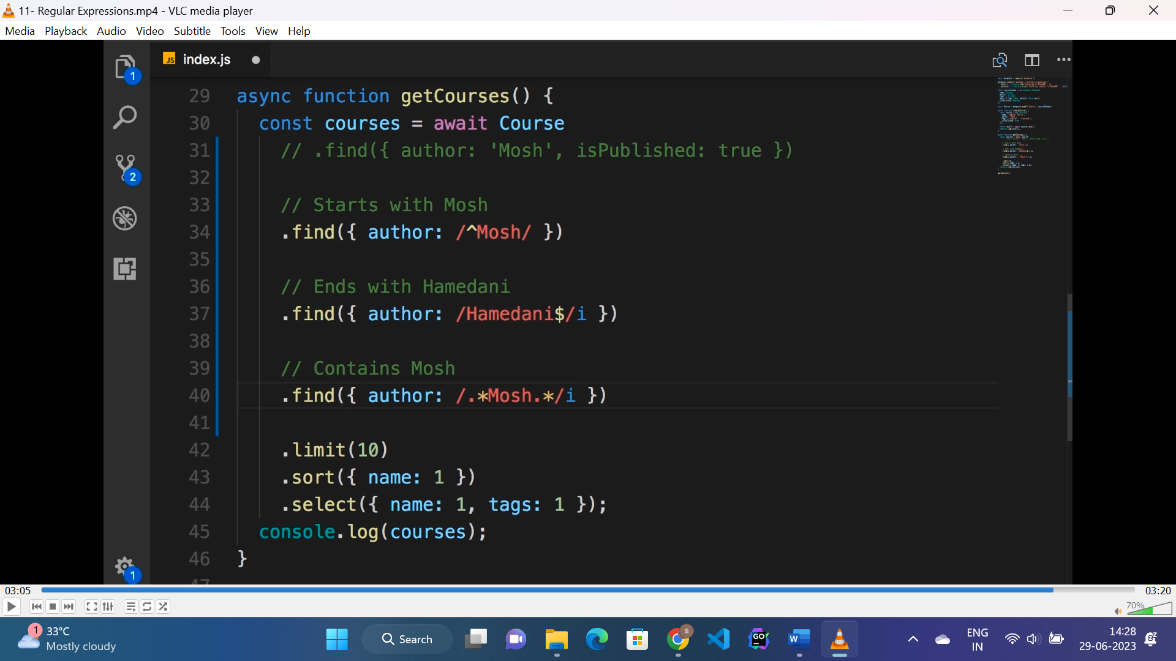

**Count method:**

* “count()” method is used to count the number of documents available for the given filter.

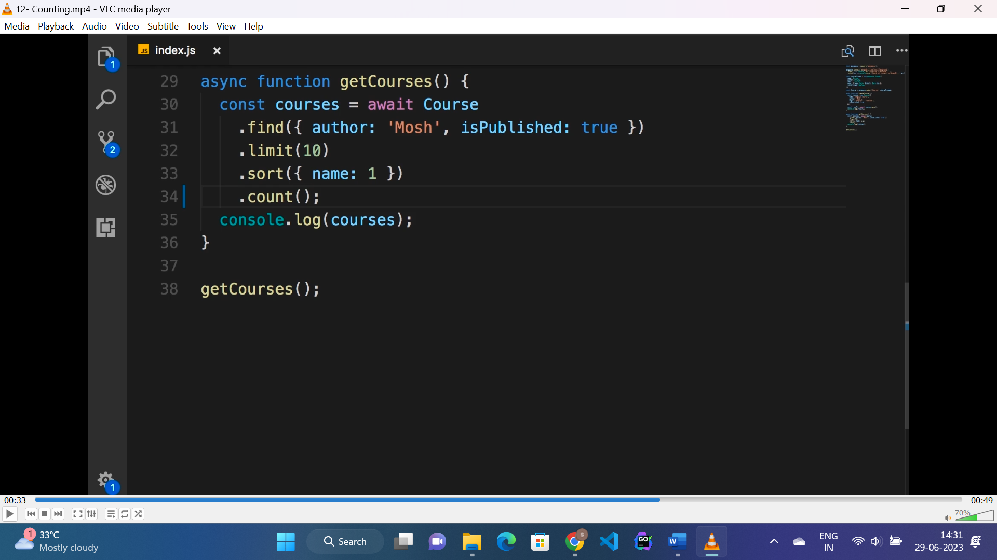

* Here “count()” method returns the number of documents available with filter “name: mosh” and published “true”.

**Pagination:**

* To apply pagination below formula is used.

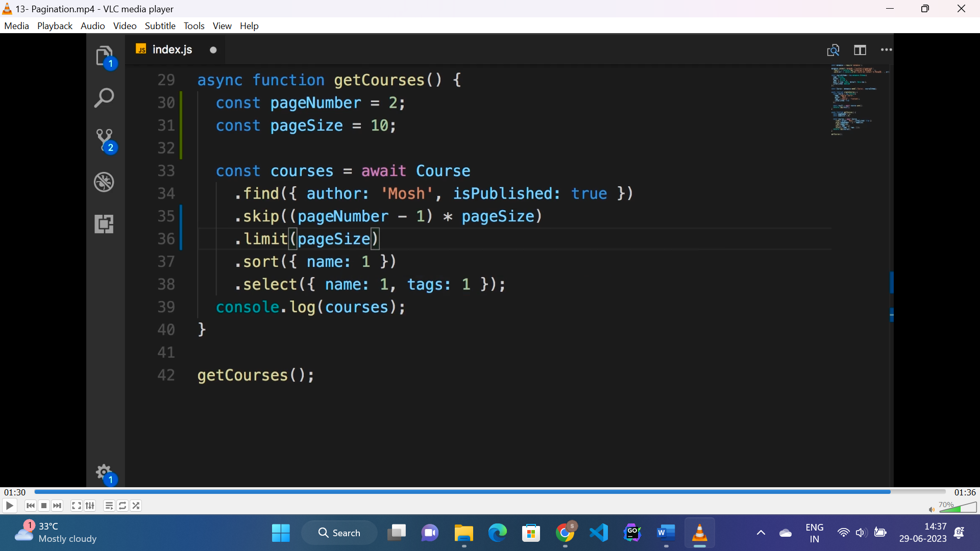

* “skip()” method skips the number of documents from the results.
* “limit()” method limits the number of documents to be shown after “skip()”.

**Updating data using mongoose:**

**1st approach**

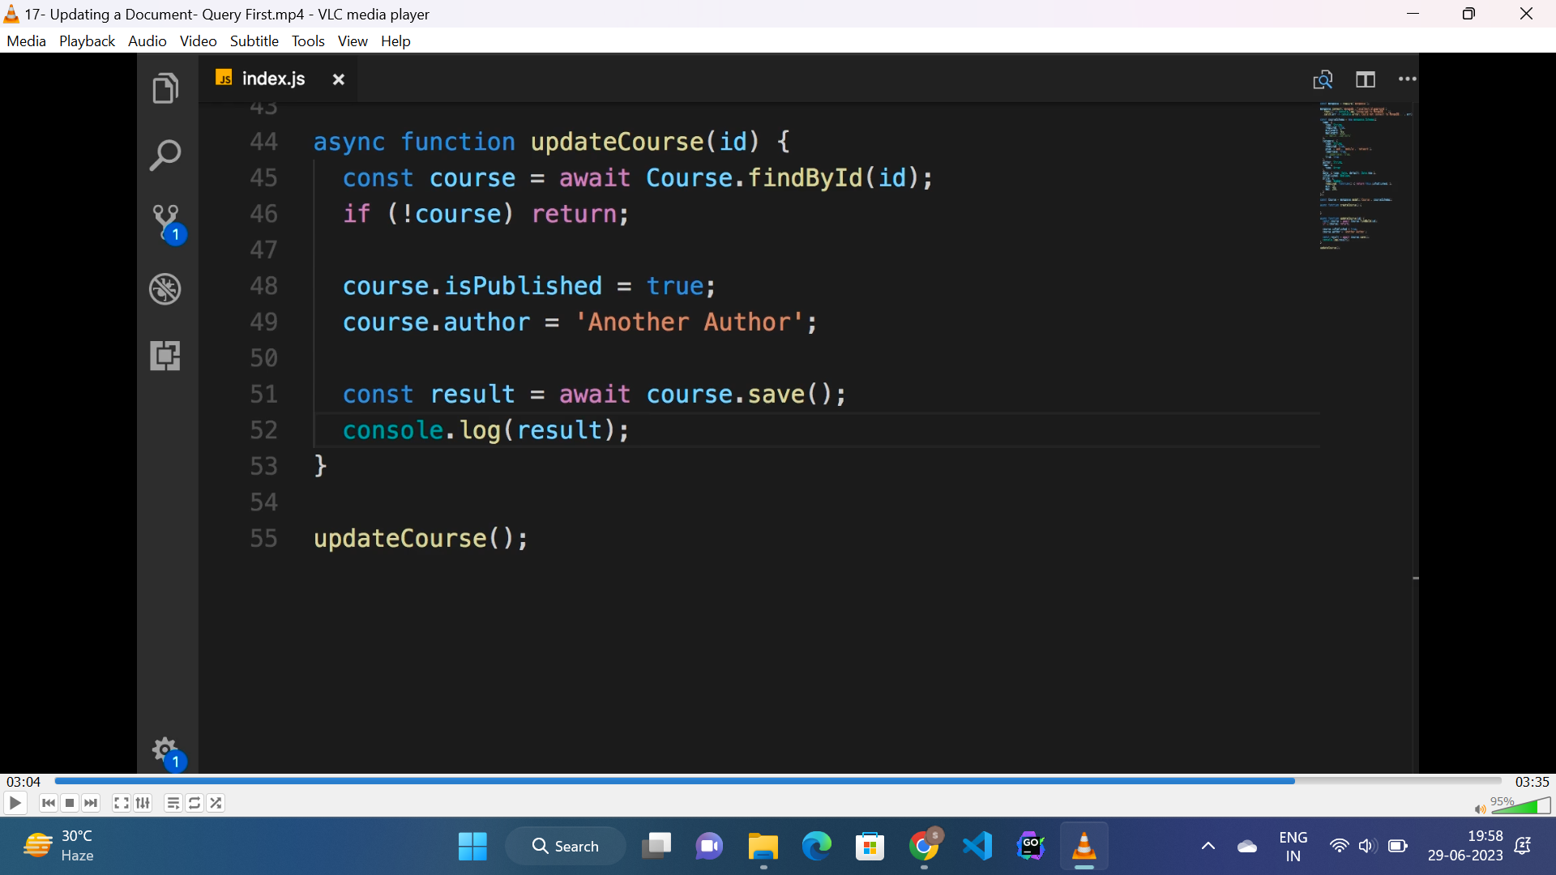

* Find the course by id.
* update the required property.
* Call the save method.

**2nd approach:**

* Update the course directly by calling “update()” course.
* Pass is as first parameter as a object and use “$set” method to update the fields of the document.
* This will return the result as rows effected in this upadate.
* We can also call “findByIdAndUpdate()” if we want the updated object(document) in return.

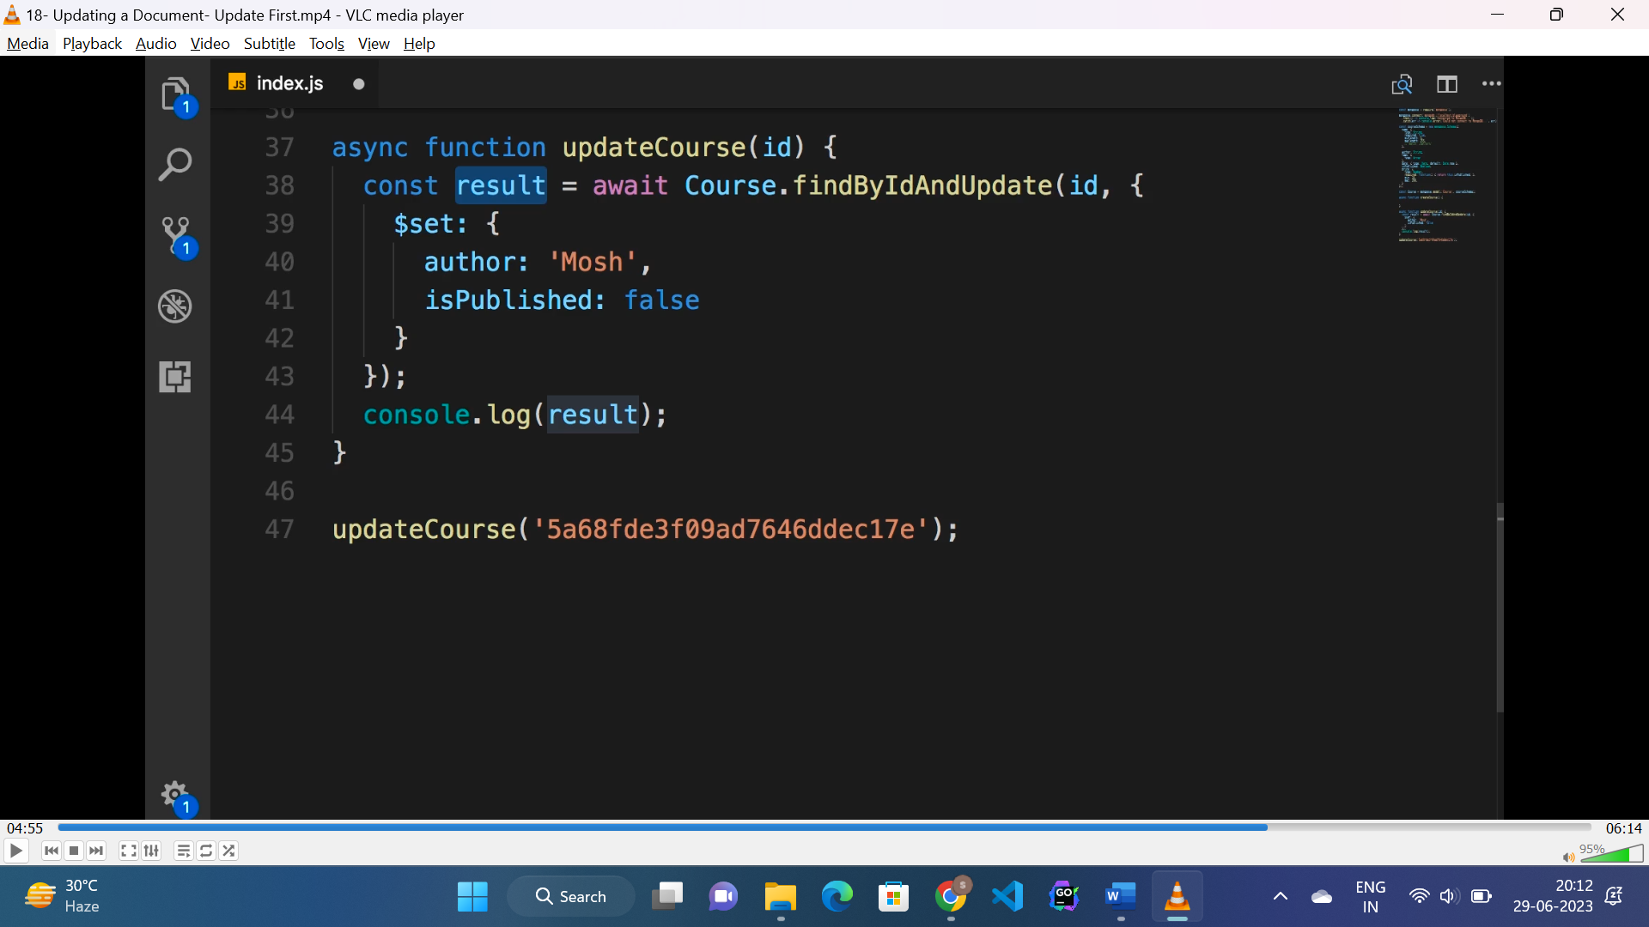

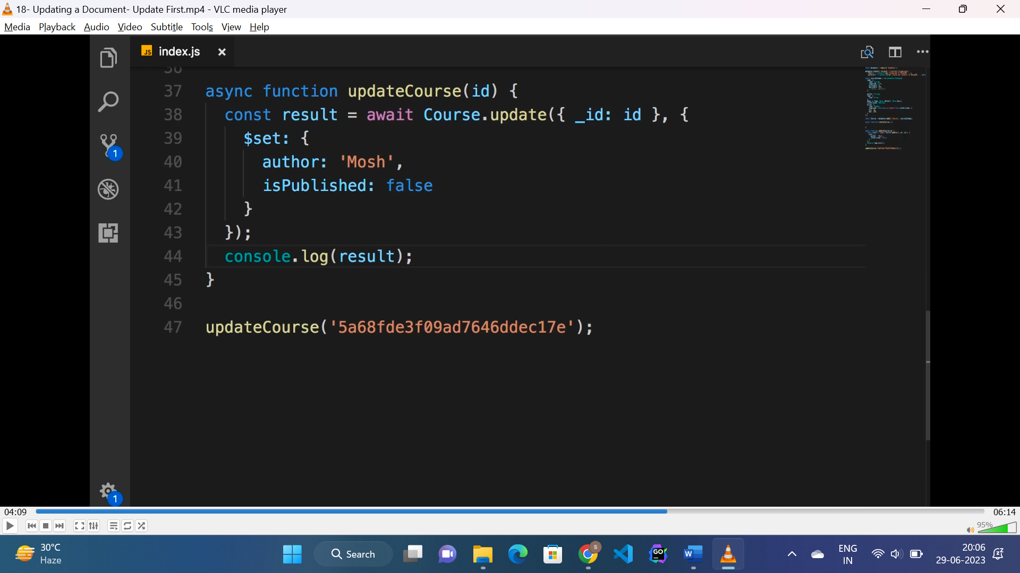

**Delete using mongoose:**

* To delete data we can use “deleteOne()” for deleting one document.
* “deleteMany()” for multiple document.
* “findByIdAndDelete()” if we want the deleted document in return.

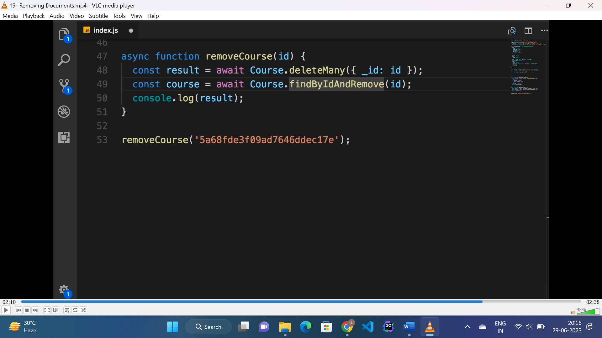

**Inbuild mongoose validators:**

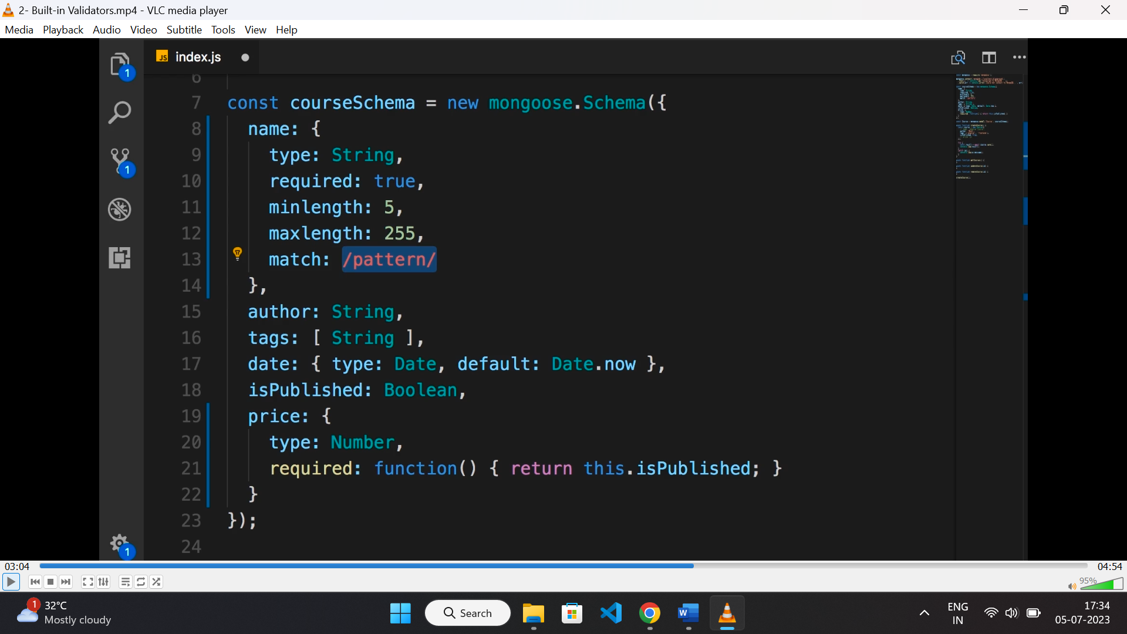

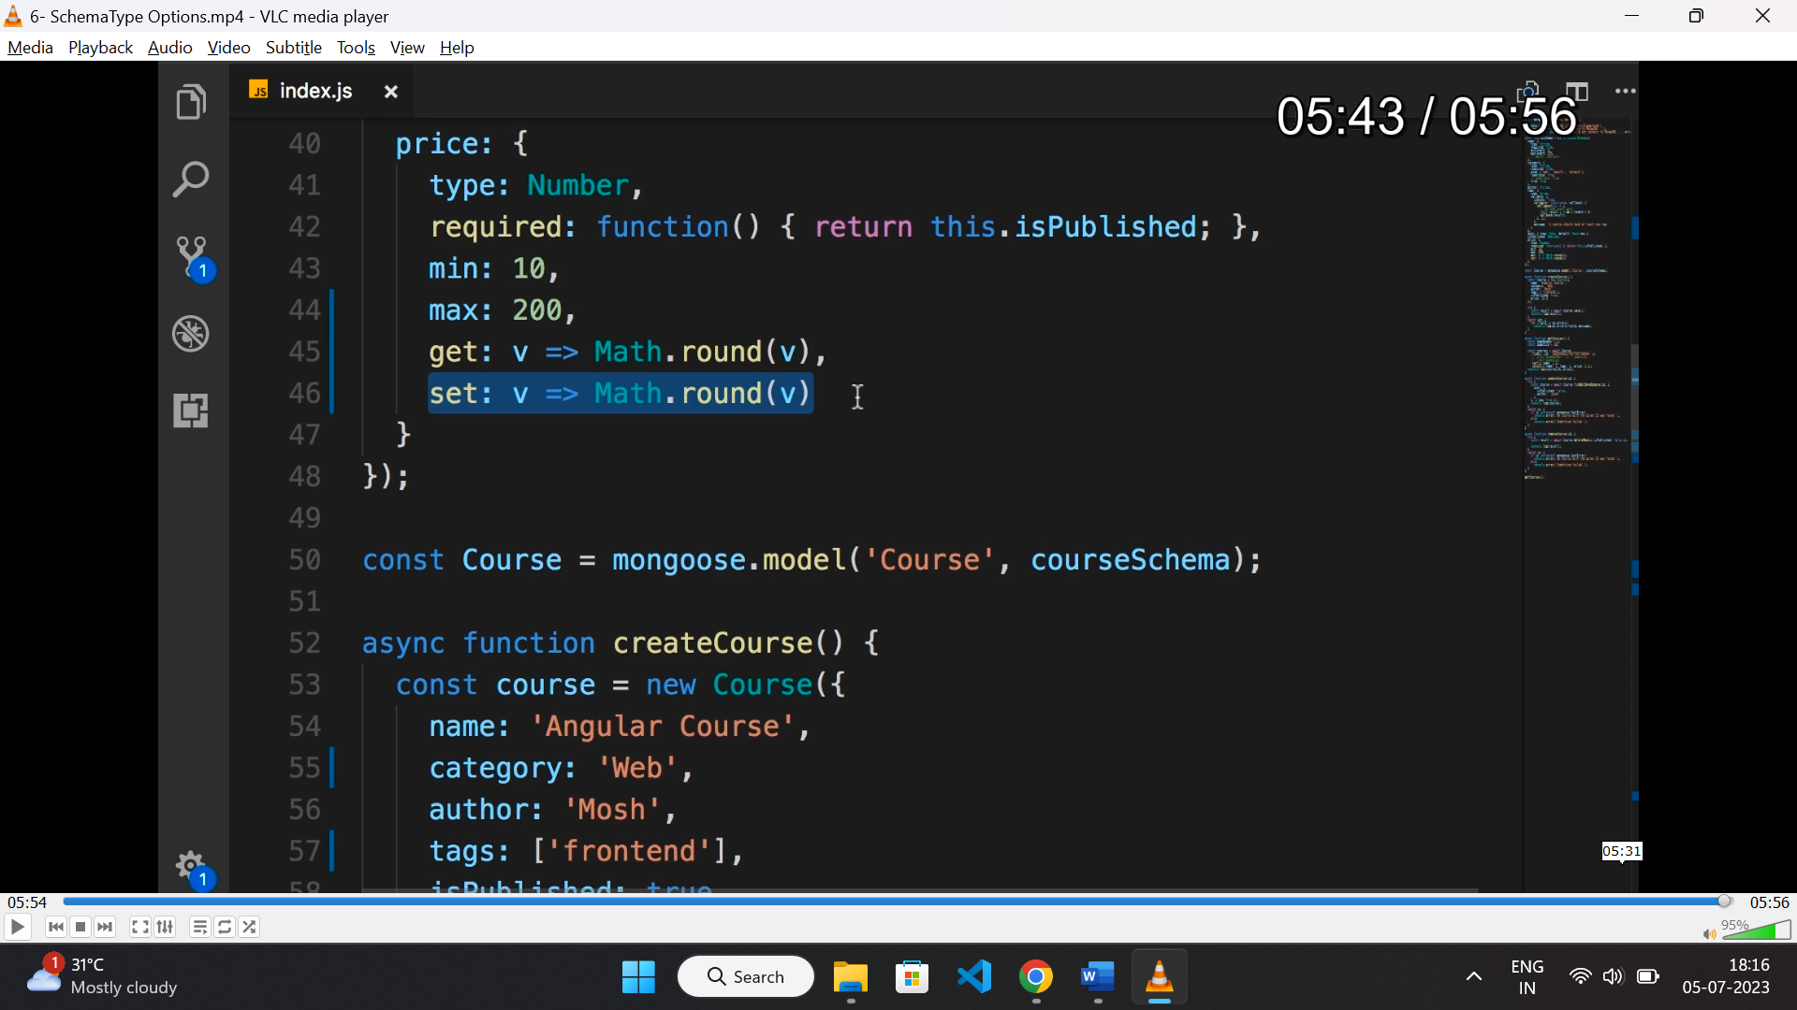

* Built-in validator for string are:
* Min length
* Max length
* Required
* Regx
* Enum (value to fall in array of values)
* Lowercase: true
* Uppercase: true
* Trim: true
* Unique: true
* Validator for number are:
* Required
* Min
* Max
* Get (used to get value with executed callback logic)
* Set (used to set value with executed callback logic)

**NOTE:** required can be “Boolean” or a callback function returning Boolean value.

**Custom validator In mongoose:**

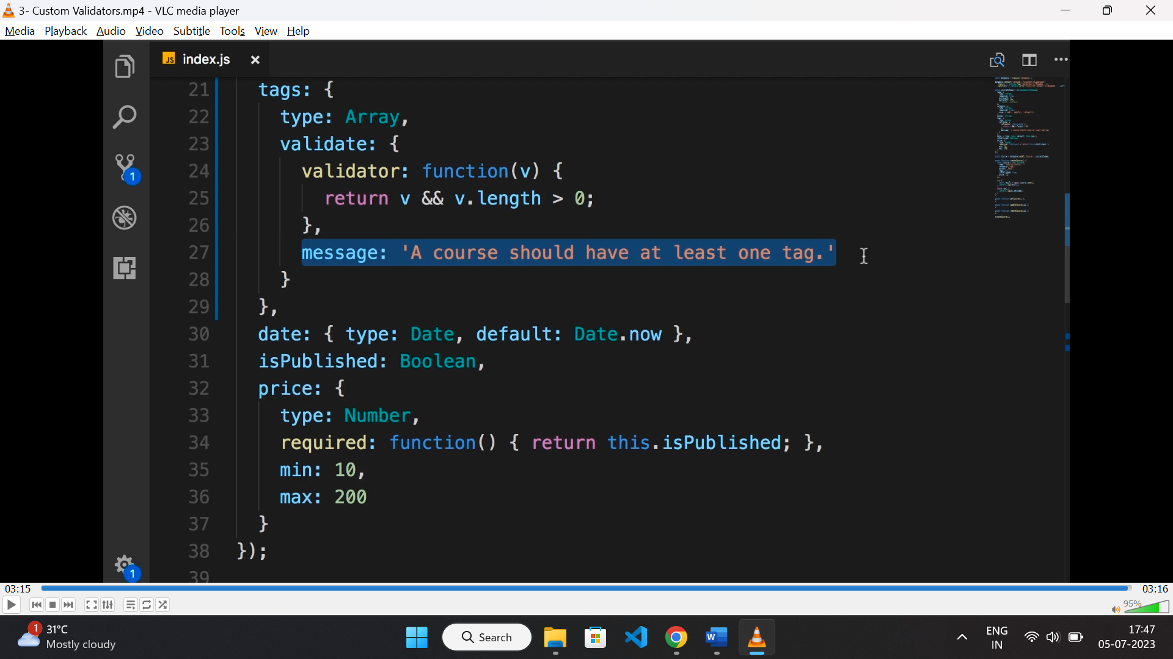

* Mongoose schema fields can have a ‘validate’ property which contains ‘validator’ and ‘message’.
* If validator fails the ‘message’ is for fallback.
* Here ‘validator’ returns true, if length of array > 0 .

**Async validator:**

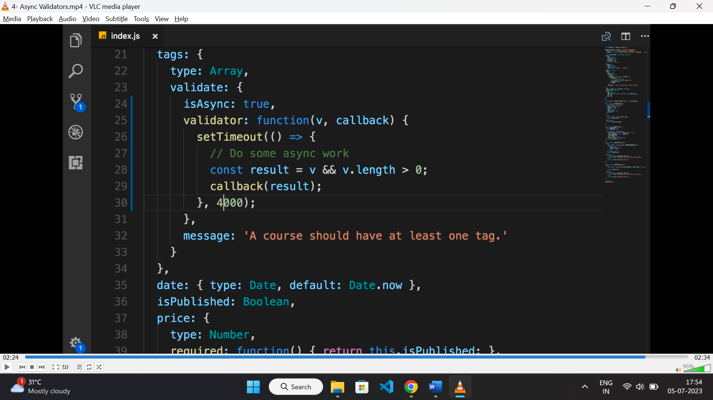

* Same as above validator except it has a property “isAsync: true”, and then pass a callback function to validator function.
* Pass the result to the callback.

**Handling multiple field errors:**

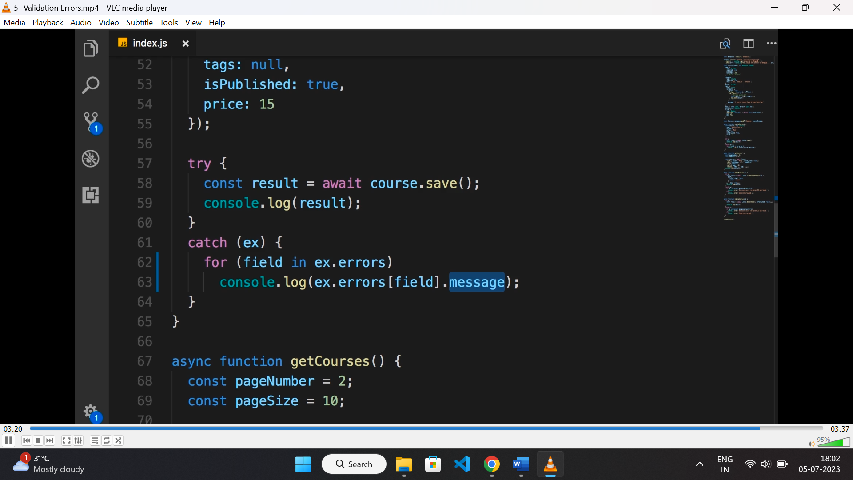

* If we face multiple field validation error, then we can loop error to print messages.

**Referencing documents in mongodb:**

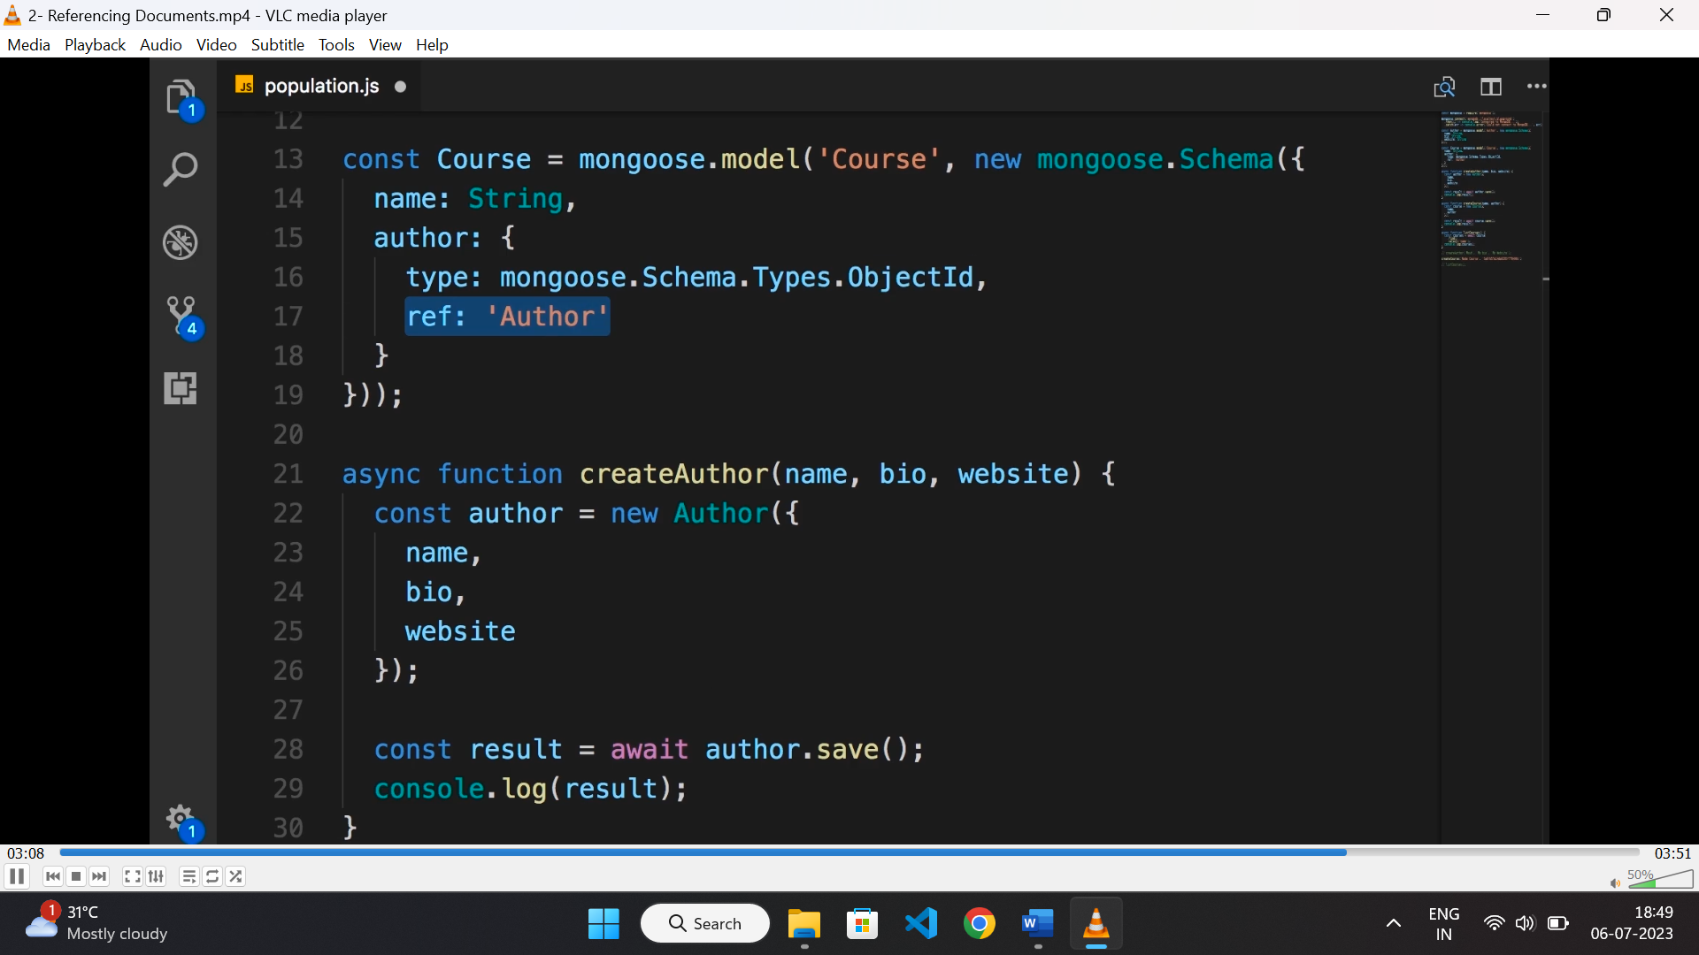

* For referencing a document to another document of another collection, we need to provide the “objectId” of that document and the “collection” name of the document.
* While creating the schema we need to provide the type as “objectId” and ref as collection name.
* While querying mongodb we can use “populate” method for populating author of the given id.

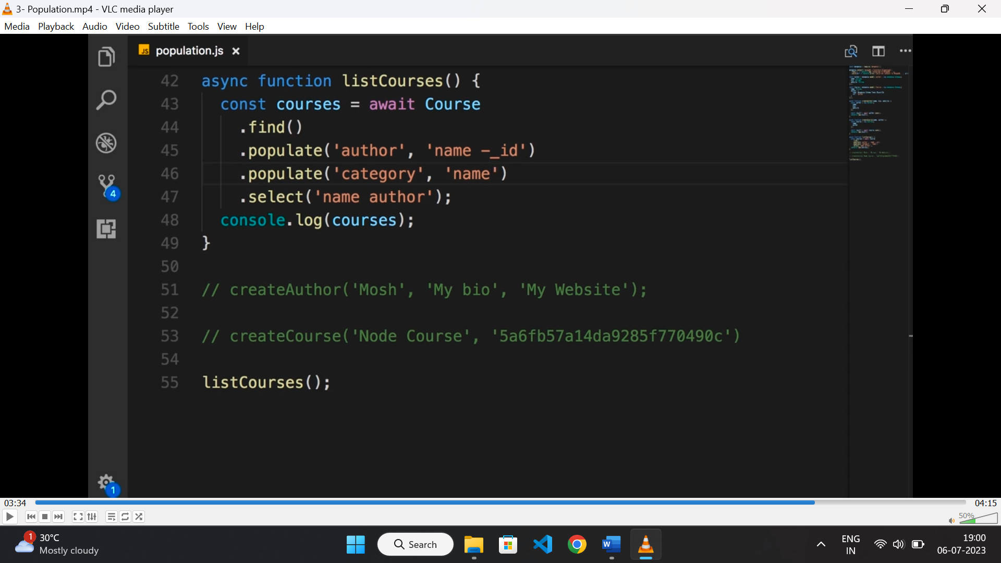

* Here populate method takes 1st argument as the property name which is “author” here, since author is linked to a document it will query the collection with given “id” then will display only the given property in 2nd argument.
* “-_id” is to exclude the “_id” property.

**Embedding document:**

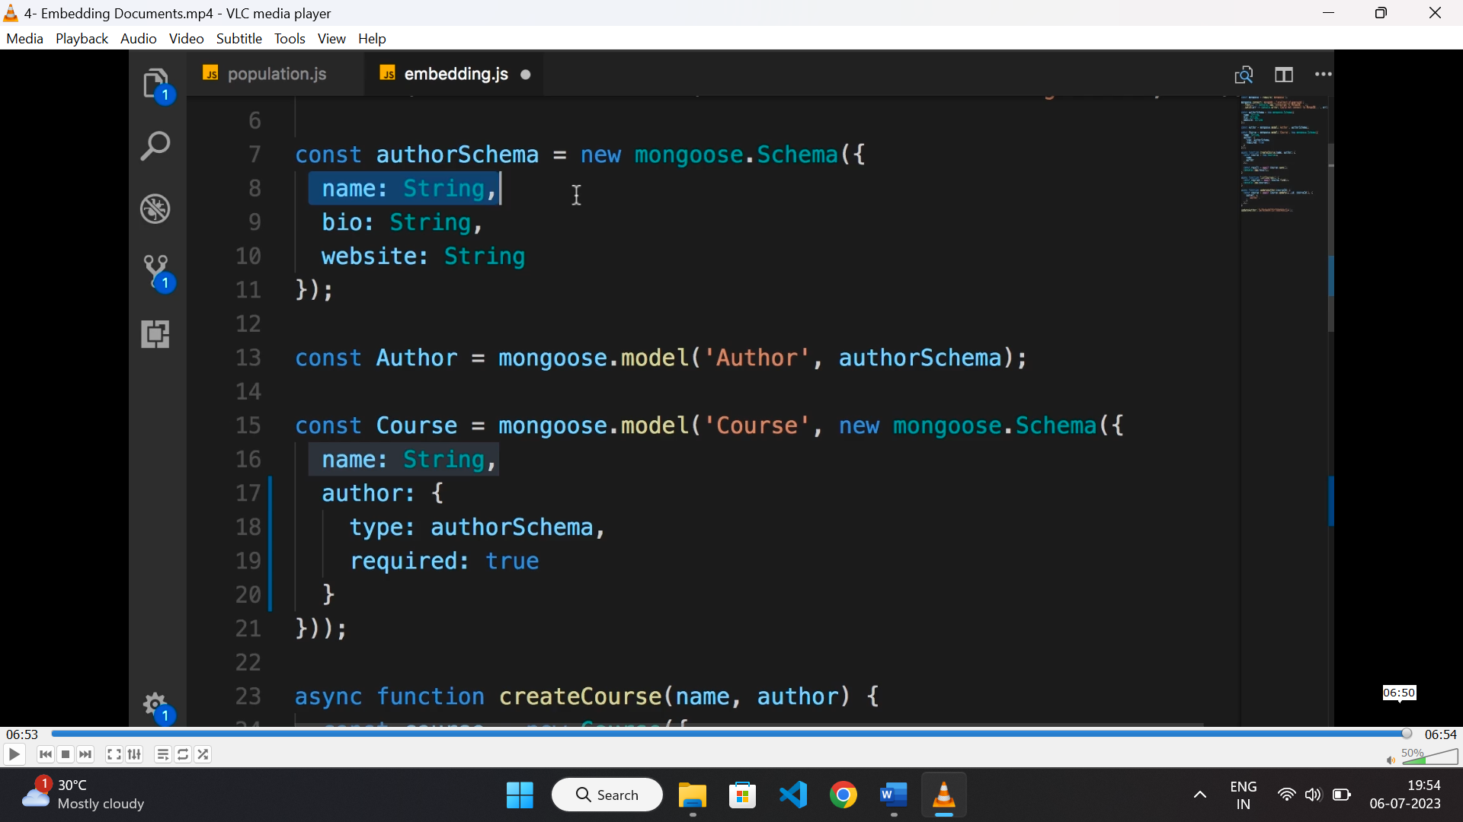

* here we are defining one schema inside another.
* To pass value while creating document of the same, we need to pass the schema of the nested document directly.

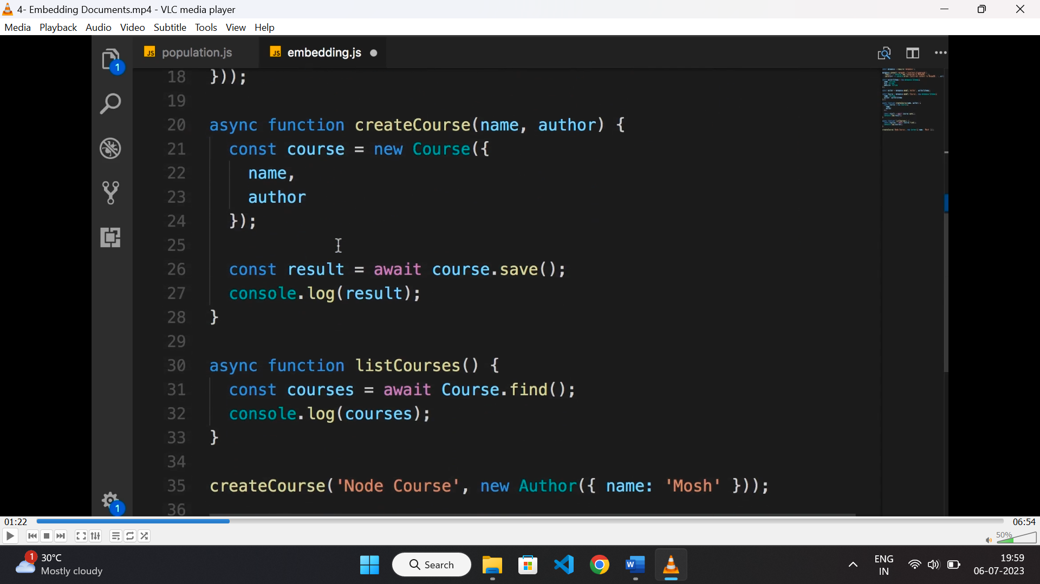

* we can only update the document on its parent context.

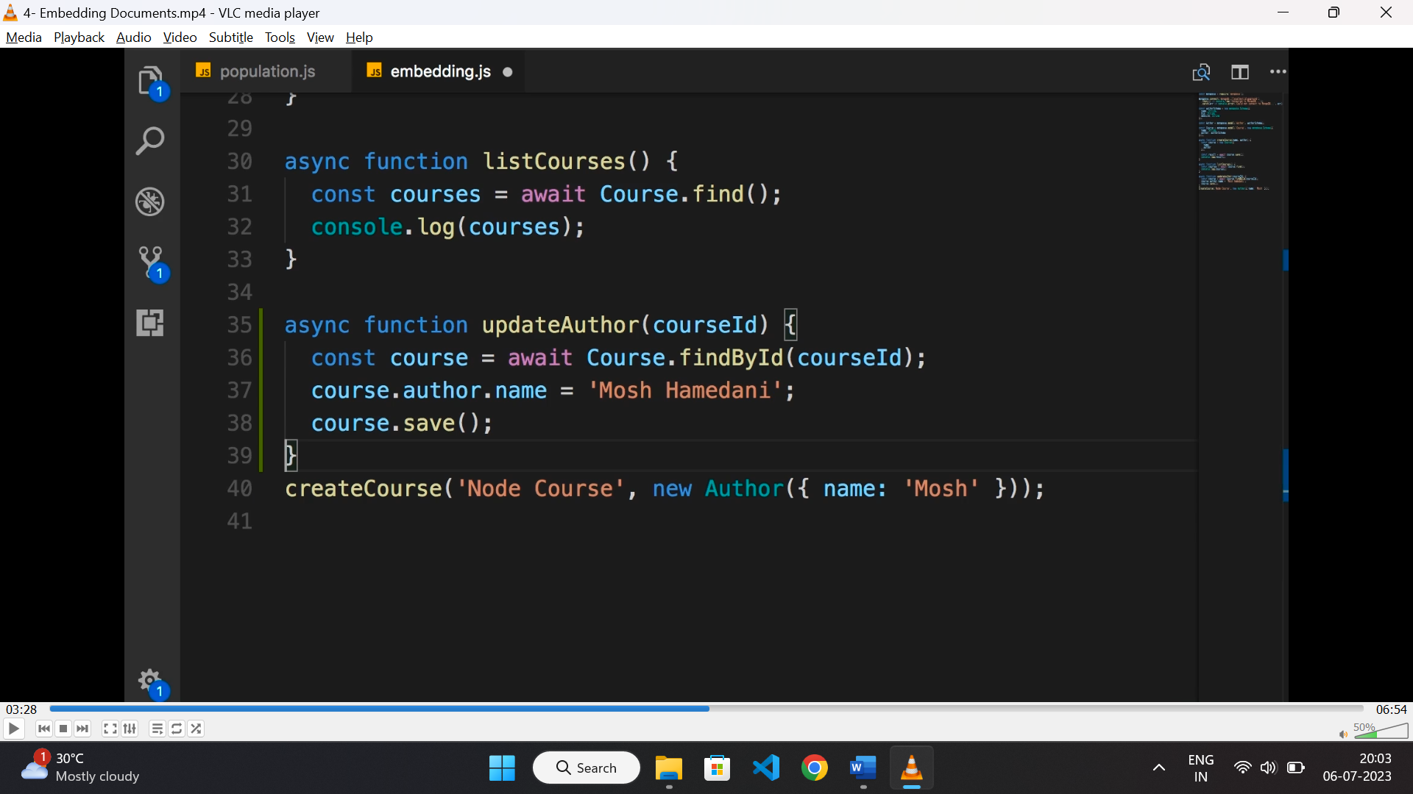

* or we can update directly as below.

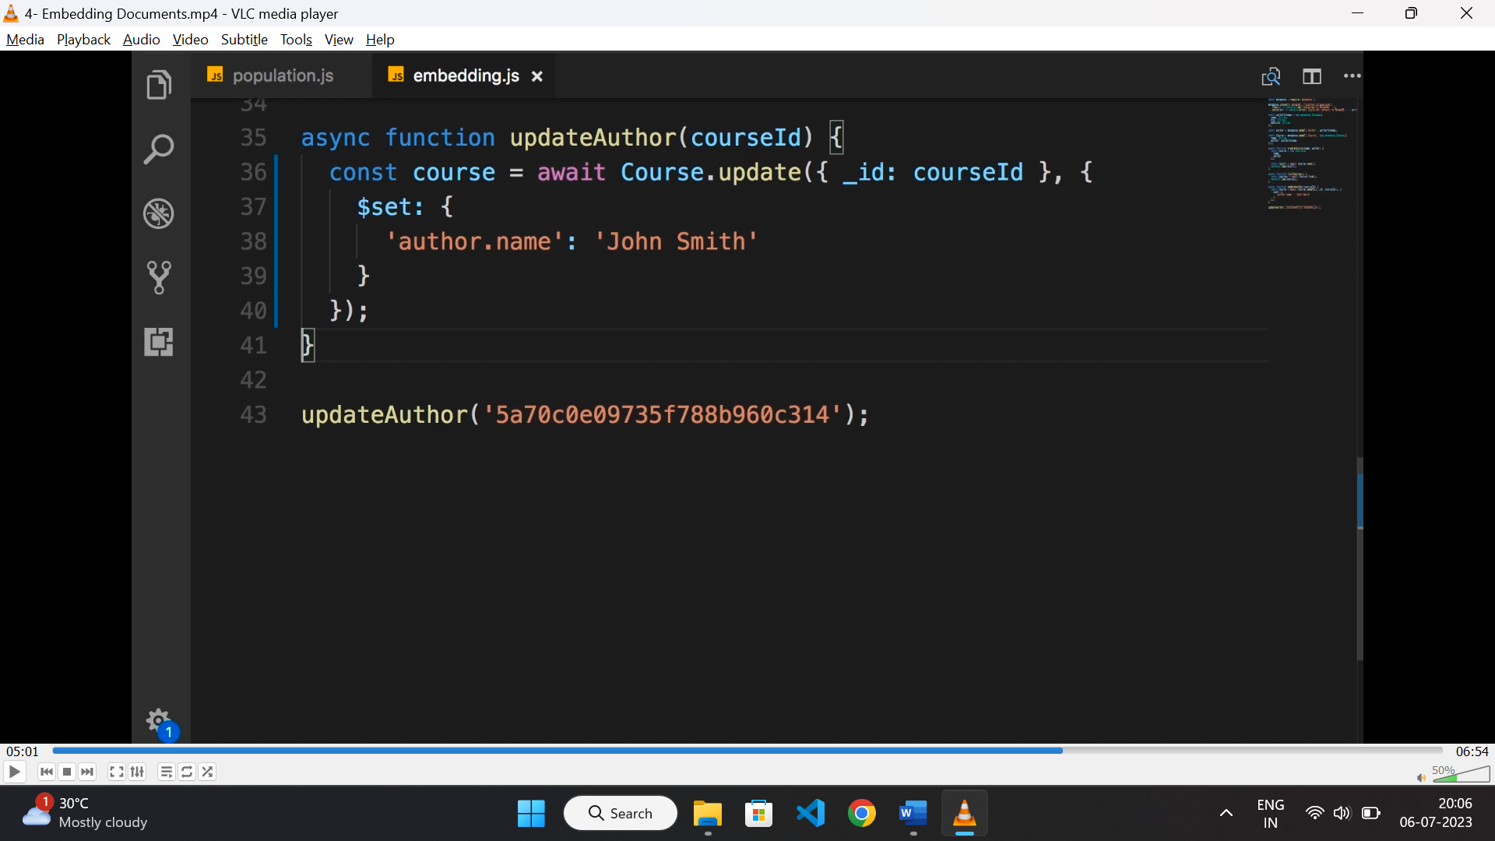

* we can delete the sub document as below using “$unset” property.

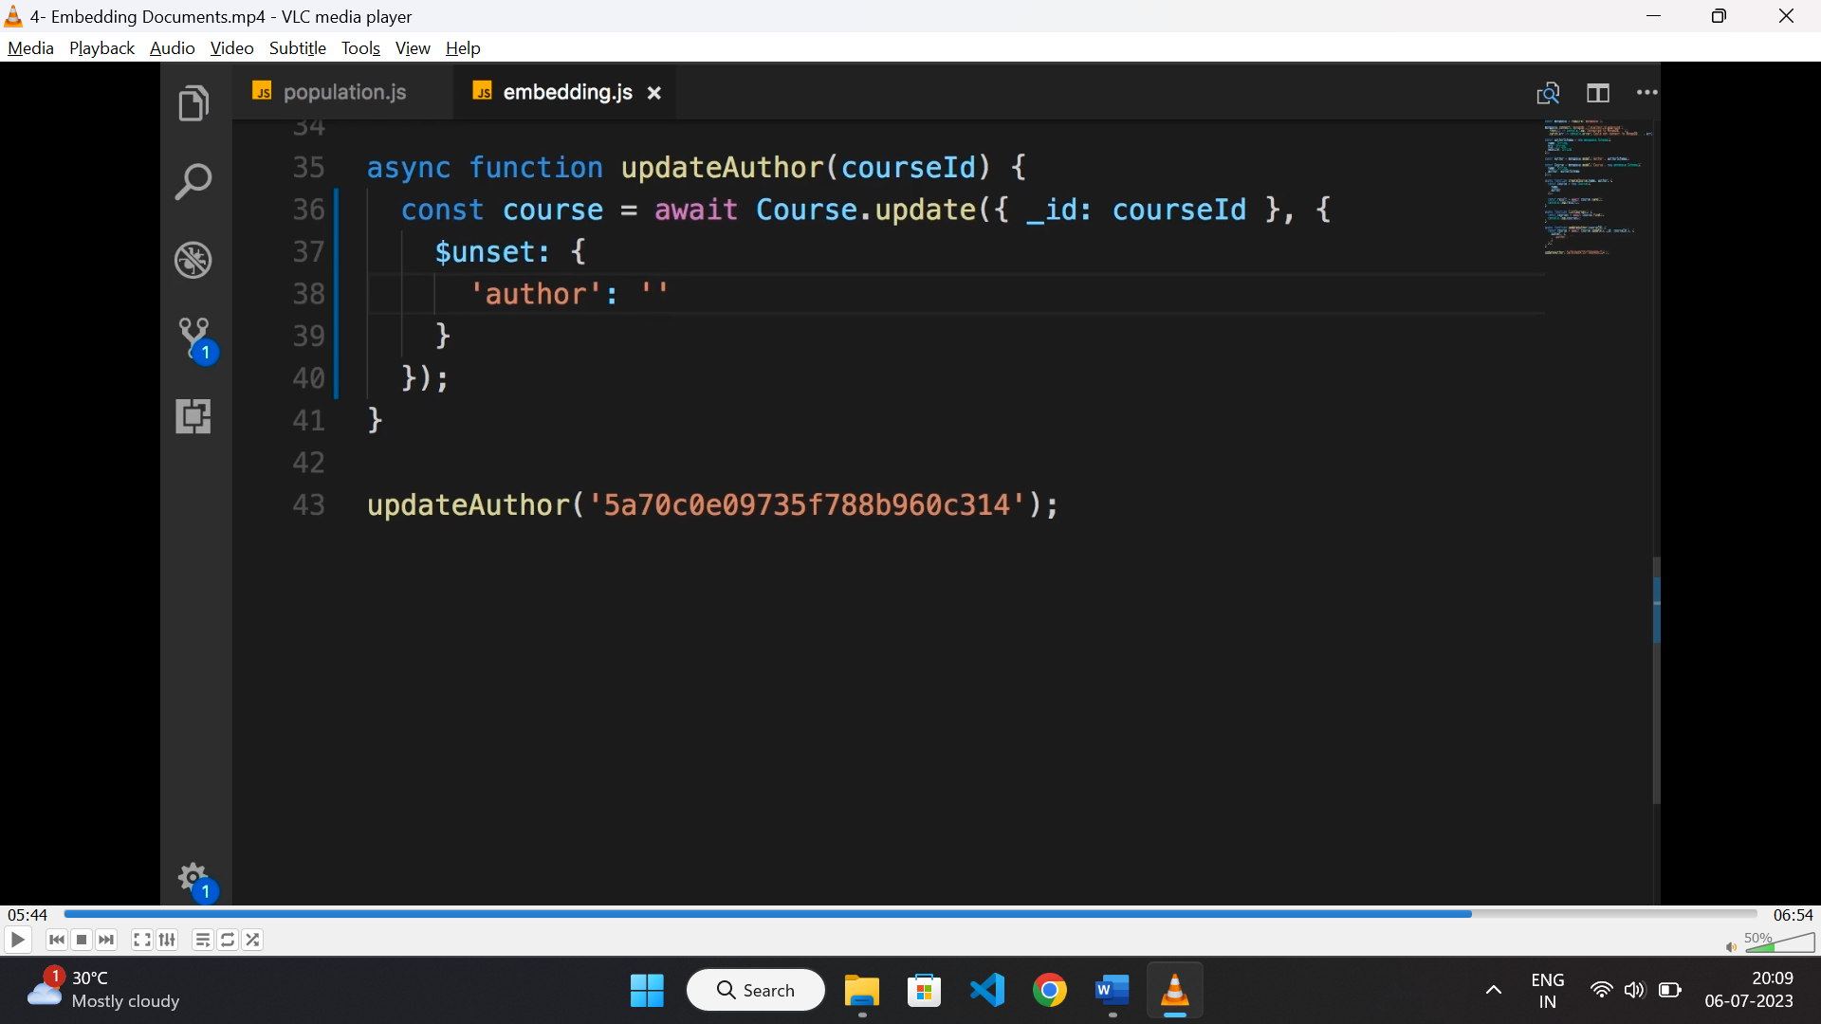

* similar way we can embed multiple documents as an array.

**Authentication:**

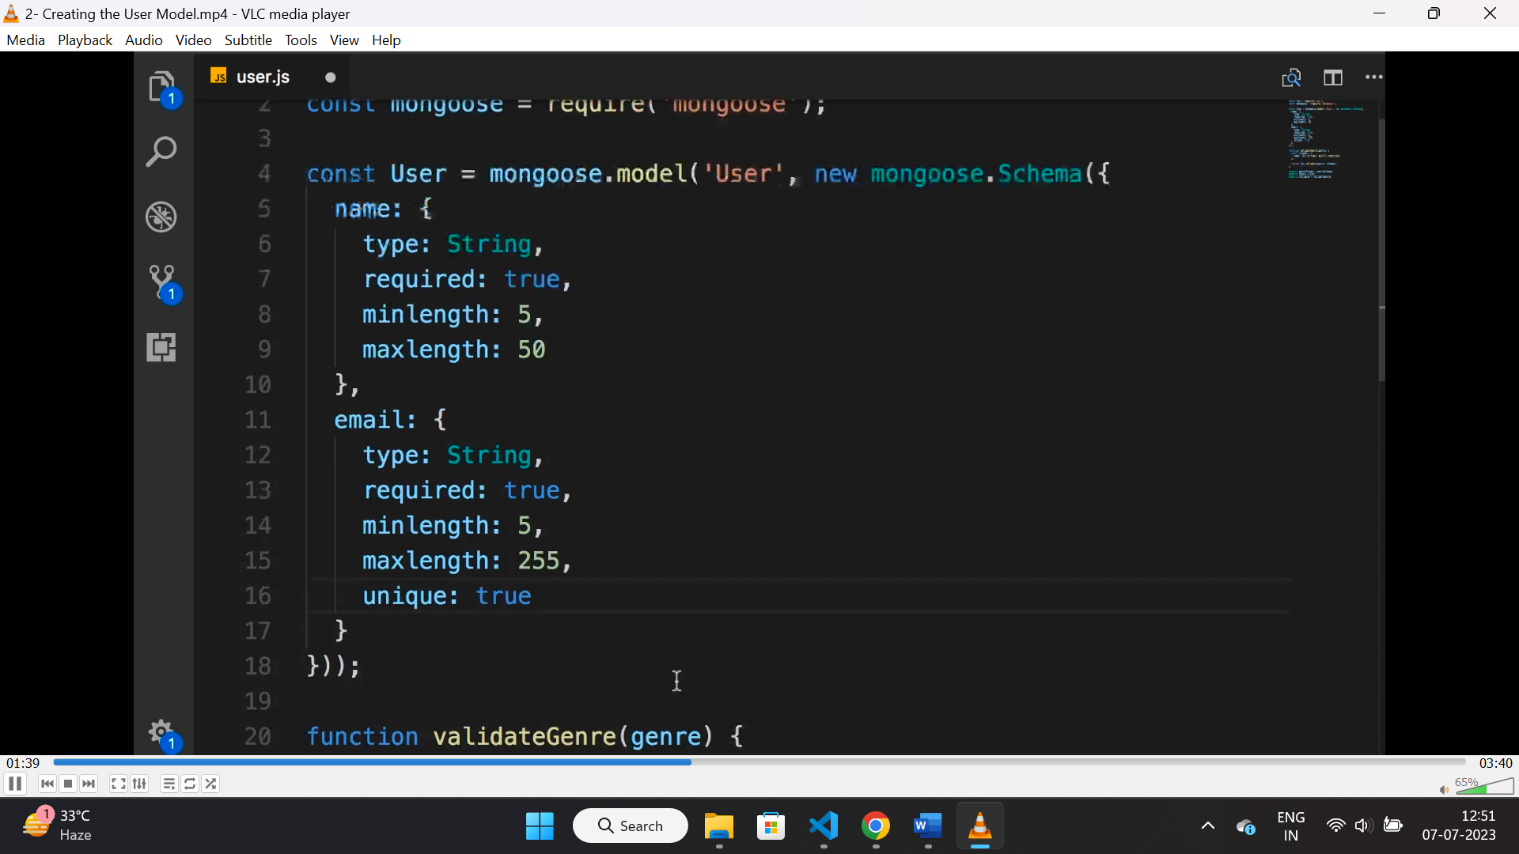

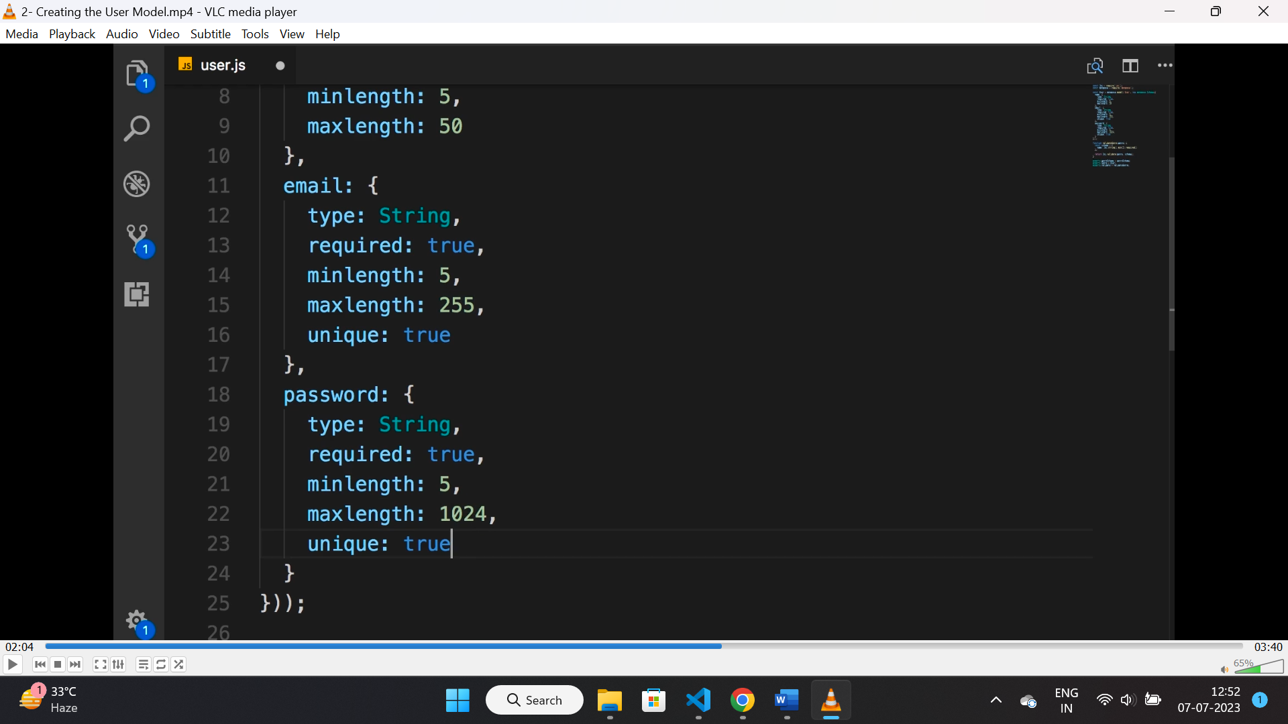

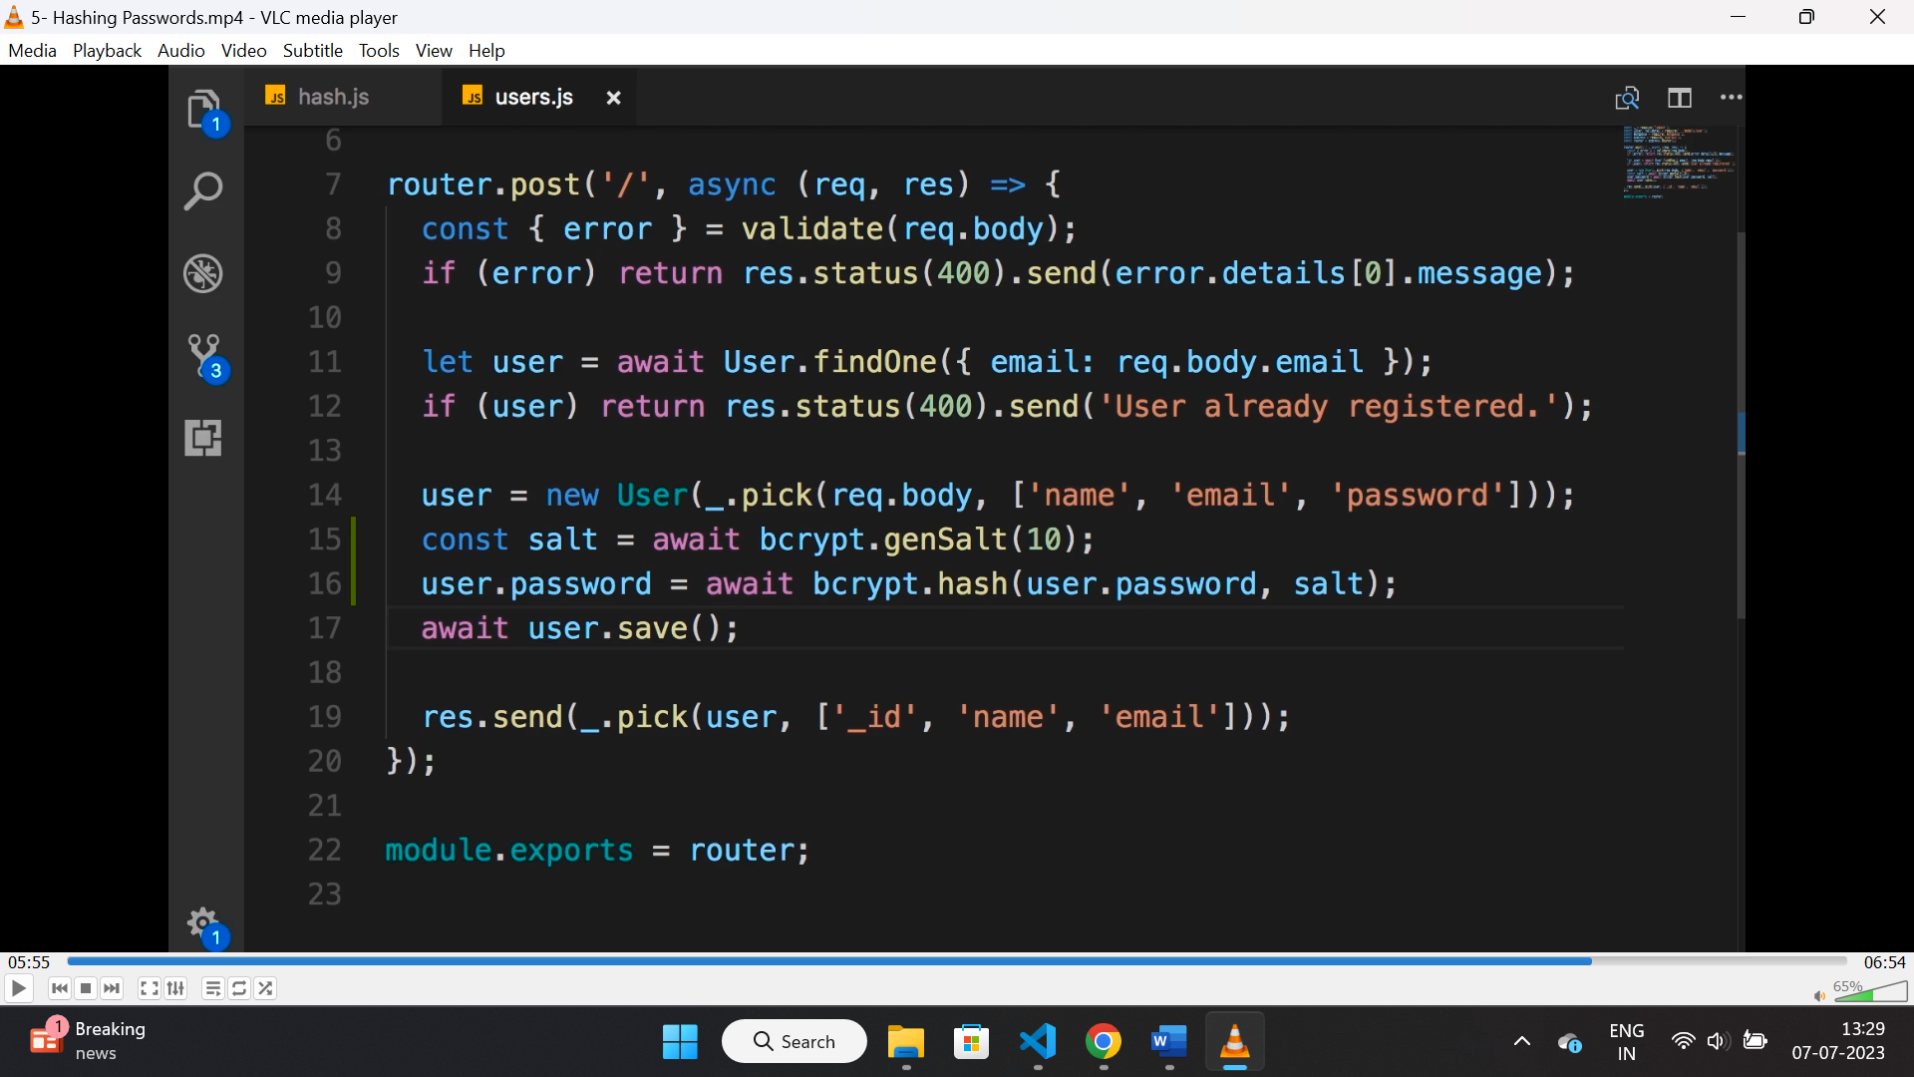

**JWT:**

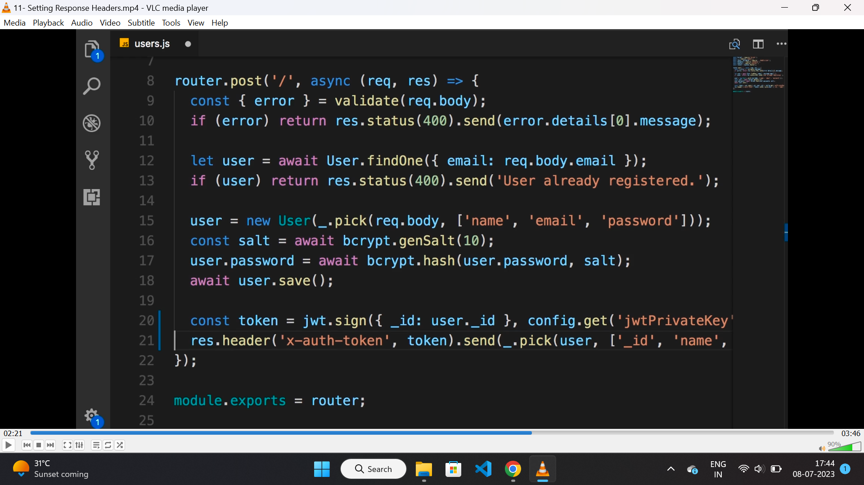

**Parsing JWT tokens:**

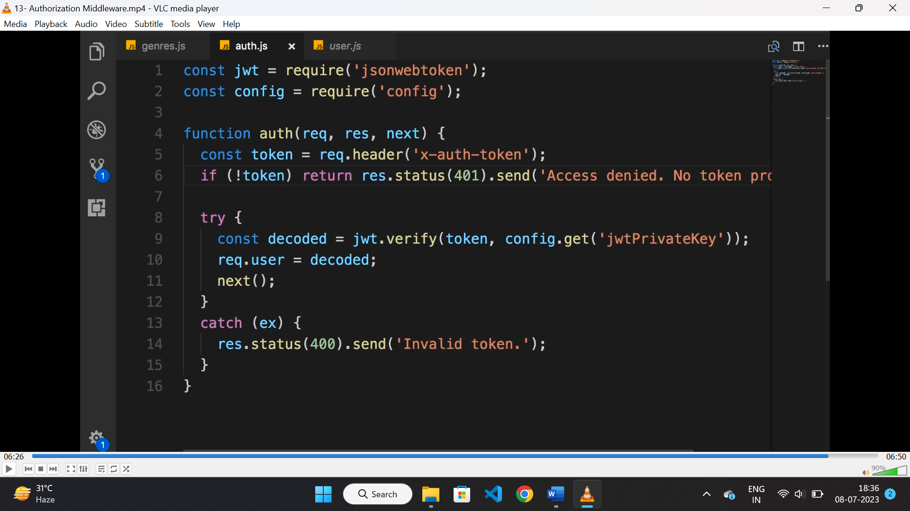

* we can use a middleware function for parsing token for validation of incoming request.

**Steps:**

* get the token from the header.
* Verify the token using “jwt.verify()” method.
* If valid call the “next()” method.

**Role based authentication:**

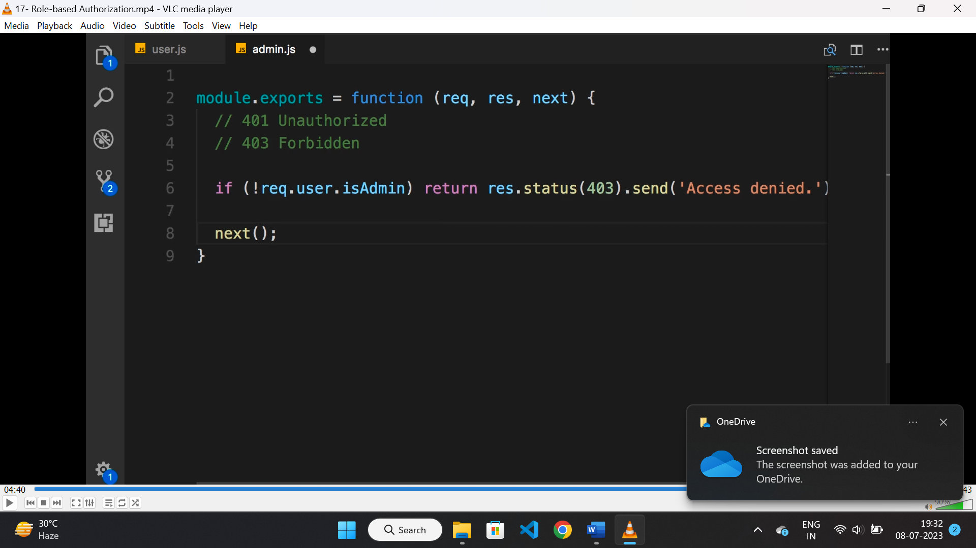

* Create a middleware to check admin role of user.
* Return “access denied” if not admin.

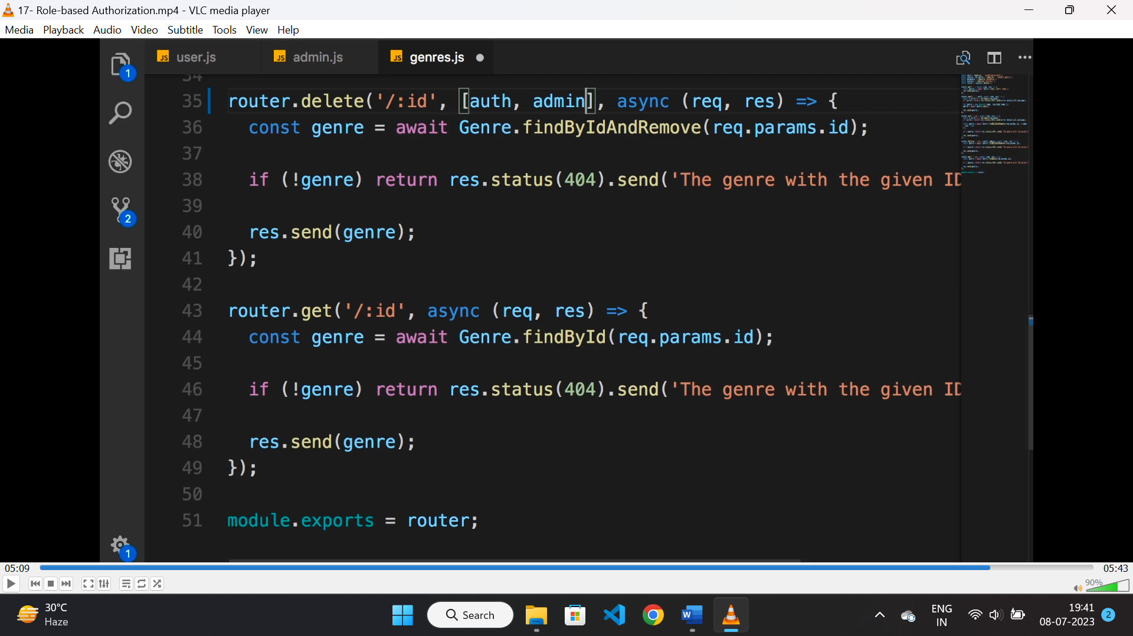

* Add the auth middleware and admin middleware before accessing the route handler.

**Managing authorization in big app:**

* In big application the role will be added as a part of jwt.
* In middleware we will check role from jwt.
* There will set of operation array of different user.
* If the requested route method exist on that array for that user role then only the user will be allowed for that route handler, otherwise not.